TWO-LEVEL QR CODE FOR PRIVATE MESSAGE SHARING AND DOCUMENT AUTHENTICATION

Abstract:

The quick response (QR) code was designed for storage information and high-speed reading applications. In this paper, we present a new rich QR code that has two storage levels and can be used for document authentication. This new rich QR code, named two-level QR code, has public and private storage levels. The public level is the same as the standard QR code storage level; therefore, it is readable by any classical QR code application. The private level is constructed by replacing the black modules by specific textured patterns. It consists of information encoded using q-ary code with an error correction capacity. This allows us not only to increase the storage capacity of the QR code, but also to distinguish the original document from a copy. This authentication is due to the sensitivity of the used patterns to the print-and-scan (P&S) process. The pattern recognition method that we use to read the second-level information can be used both in a private message sharing and in an authentication scenario. It is based on maximizing the correlation values between P&S degraded patterns and reference patterns. The storage capacity can be significantly improved by increasing the code alphabet q or by increasing the textured pattern size. The experimental results show a perfect restoration of private information. It also highlights the possibility of using this new rich QR code for document authentication.
KEYWORDS: QR code, two storage levels, private message,document authentication, pattern recognition, print-and-scan process.

LIST OF CONTENTS
Page No
List of Figures viii
List of Tables
ix
1. Introduction
2. Literature Survey
2.1 Introduction
2.2 History
2.3 Purpose
2.4 Requirements
2.5 Technology Used
2.6 Research Methodologies
3. Fundamental Concepts on (Domain)
3.1 Domain Fundamentals & Description
4. System Analysis
4.1 Existing System
4.1.1 Drawbacks
4.2 Problem statement
4.3 Proposed System
4.3.1 Advantages
4.4 Modules Description
4.5 Feasibility Study
4.5.1 Economic Feasibility
4.5.2 Operational Feasibility
4.5.3 Technical Feasibility
5. System Requirements Specification
5.1 Introduction
5.2 Purpose
5.3 Functional Requirements
5.4 Non Functional Requirements
5.5 Hardware Requirements
5.6 Software Requirements
6. System Design
6.1 System Specifications
6.2 System Components
6.3 DFD’s
6.4 UML Diagrams
7. Implementation
7.1 Technology Description

8. System Testing
8.1 Testing Methodologies
8.2 Test cases
8.3 Result Analysis
9. Conclusion and Future Enhancements
9.1 Conclusion
9.2 Scope for Future Enhancements
10. References
Appendix:
- Sample code
- screenshots

INTRODUCTION
1 INTRODUCTION
Today, graphical codes, such as EAN-13 barcode, Quick Response (QR) code, DataMatrix , PDF417, are frequently used in our daily lives. These codes have a huge number of applications including: information storage (advertising, museum art description), redirection to web sites, track and trace (for transportation tickets or brands), identification The popularity of these codes is mainly due to the following features: they are robust to the copying process, easy to read by any device and any user, they have a high encoding capacity enhanced by error correction facilities, they have a small size and are robust to geometrical distortions. However, those undeniable advantages also have their counterparts:
1) Information encoded in a QR code is always accessible to everyone, even if it is ciphered and therefore is only legible to authorized users (the difference between “see” and “understand”).
2) It is impossible to distinguish an originally printed QR code from its copy due to their in sensitivity to the Print-and-Scan (P&S) process.

In this paper, we propose to overcome these shortcomings by enriching the standard QR code encoding capacity. This enrichment is obtained by replacing its black modules by specific textured patterns. Besides the gain of storage capacity, these patterns can be designed to be sensitive to distortions due to the P&S process. These patterns, that do not introduce disruption
in the standard reading process, are always perceived as black modules by any QR code reader. Therefore, even when the private information is degraded or lost in the copy, the public information is always accessible for reading.

The proposed two level QR (2LQR) code contains of: a first level accessible for any standard QR code reader, therefore it keeps the strong characteristics of the QR code; and a second level that improves the capacities and characteristics of the initial QR code. The information in the second level is encoded by using q−ary (q ≥ 2) code with error correction capacities. This information is invisible to the standard QR code reader because it perceives the textured patterns as black modules. Therefore, the second level can be used for private message sharing. Additionally, thanks to textured pattern sensitivity to P&S distortions, the second level can be used to distinguish the original 2LQR code from its copies.

The paper is organized as follows. We start with an introduction of QR code features and existing rich graphical codes in Section II. In addition, the distortion added during the P&S process will be discussed there. The proposed two level QR (2LQR) code as well as the proposed recognition method are presented in Section III. In Section IV, the experimental results show the efficiency of the proposed recognition methods and analyze the capacities of the proposed 2LQR code. Finally, Section V represents conclusions and perspectives.

The QR code was invented for the Japanese automotive industry by Denso Wave1 corporation in 1994. The most important characteristics of this code are small printout size and high speed reading process. The certification of QR code was performed by International Organization of Standardization (ISO), and its whole specification can be found in. A QR code encodes the information into binary form. Each information bit is represented by a black or a white module.
The Reed-Solomon error correction code [15] is used for data encryption. Therefore, one of 4 error correction levels has to be chosen during QR code generation. The lowest level can
restore nearly 7% of damaged information, the highest level can restore nearly 30%. Today, 40 QR code versions are available with different to storage capacities. The smallest QR code version (version V1) has a 21 × 21 module size. It can store 152 bits of raw data at the lowest correction level. The biggest QR code version (version V40) has a 177 × 177 module size. It can store a maximum of 7089 bits of raw data at its lowest correction level.

As illustrated in, the QR code has a specific structure for geometrical correction and high speed decoding. Three position tags are used for QR code detection and orientation correction. One or more alignment patterns are used to code deformation adjustment. The module coordinates are set by timing patterns. Furthermore, the format information areas contain error correction level and mask pattern. The code version and error correction bits are stored in the version information areas.

The QR code generation algorithm consists of information encoding using Reed-Solomon error correction code, information division on code words, application of mask pattern, placement of code words and function patterns into the QR code. The QR code recognition algorithm includes the scanning process, image binarization, geometrical correction and decoding algorithm.

.2. Literature Survey

Image Embedding in QR Code:

The QR (Quick Response) code is a two-dimensional barcode developed by the Japanese company Denso-Wave in 1994, and was approved as an ISO International Standard and Chinese National Standard in 2000. The QR code has been widely used due to its good features such as large data capacity, high speed scan, and small printout size. Increase in number of smart phones is the reason behind popularity of QR code. Smart phones are capable of decoding and accessing on line resources as well as it has high storage capacity and high speed of decoding. QR codes are used in a various applications, such as accessing websites, initiate phone calls, reproduce videos or open text documents and data storing purposes. An important problem of QR codes is its noisy looks. To improve the appearance of QR code and to reduce noisy black and white random texture has generated great interest for algorithms capable of embedding QR codes into images without losing decoding robustness. There have been many efforts to improve the appearance of such embeddings. The main challenge of any embedding method is the embedded result should be decodable by standard applications. The embedding introduces changes in the luminance of the code, distorting the binarization thresholds and thus increasing the probability of detection error. The second challenge is the problem of using the entire area of the code in which the image or logo is to be embedded. This cannot be done by simply replacing information modules with the desired image. A good embedding method should decrease the number of corrupted modules and uses the utmost area. The proposed method is based on the selection of a set of pixels using genetic algorithm. The concentration of pixels and its corresponding luminance are optimized to minimize a visual distortion. Distortion metric is subject to a constraint in the probability of error.

QR code consists of black and white square blocks called as modules of a QR code. Each module is assigned a single bit value. Information is encoded into the QR modules. A dark module is binary one and a light module is binary zero. A codeword contains 8 bits of information. There are 40 versions of QR code. A QR code with version V have (17 + 4V) × (17 + 4V) number of modules. Therefore version 1 has 21 × 21 modules whereas version 40 corresponds to 177 × 177 modules. Fig. 1 shows the structure of a QR code. Finder pattern contains three identical square shape located at the three corners of QR code. Finder pattern is the most important pattern which enables the detection of QR code. Alignment patterns are also essential to locate, rotate and aligning the QR code. Finder pattern, timing pattern and alignment pattern are collectively known as function pattern region of QR code. Alignment patterns are observed with version number 2 and onwards however version number 1 does not have any alignment pattern. Encoding region within the green color consists of data and error correction code words. Data code words are of two types i.e. information code words which stores the actual information and the second is padding code words. Encoding region stores the data, parity modules and decoding information in the form of a code words. A codeword consist of a block of 8 modules. Quite Zone is the guard region of QR code. QR code utilizes RS (Reed Solomon) codes for error correction. A QR code contains multiple RS codes where one RS code is sufficient to store the message. The remaining RS codes are usually used to store non meaningful messages [2]. There are 4 types of error correction level i.e. L, M, Q and H which can recover 7%, 15%, 25% and 30% of errors in the code words respectively.

There have been a lot of efforts to improve the appearance of QR code. The base strategy of such work is to find the best group of QR modules to substitute by the image or logo in the QR code. The method presented in [3] proposed that, there are three areas to replace the QR module by the image or logo. These areas include data codewords, padding codewords and the error correcting codewords. Depending on the error correction level of QR code, pad characters have been changed. The size of the embedding image in the QR code is identified and then the image is implanted in the identified region of QR code. The size of the image which is to be embedded is increased and tested the readability of QR embedding to find largest size of which the image could be embedded except the finder pattern of QR code. Author concludes that if the numbers of characters in the QR code is decreased then the larger image can be embedded. The second approach [12] of embedding is based on the modification of the pixel’s luminance. The luminance of central pixels is modified since this is the area usually sampled by the decoder. This approach uses the entire area of the code for embedding except the finder and alignment pattern. The approach in [10] performs the blending which combines the color image C and the QR code Q based on the luminance of color image and the binary value of QR code. The blending of C and Q to produce an output B is accomplished by replacing pixels of Q with those of C. Author assumes that pixels of Q are normalized so that white pixels have a luminance of 1, and black pixels have a luminance of 0. This algorithm ensures that the blended output image preserves the bright part of color image when the pixel value of the QR code equals to 1, and dark part of the color image when pixel value is 0. Cox proposed a complicated algorithm [19] to embed a binary image into a QR code during the data encoding stage of generating the code. He carefully investigated the internal structure of QR code and the logic behind data encoding, and designed an algorithm to encode image content as redundant numeric strings appended to the original data. However this technique works only for URL type data string and the quality of embedded image is limited by the length of encoded URL.

Robust Message Hiding for QR Code:

Response Code (QR code) is widely used in daily life in recent years because it has high capacity encoding of data, damage resistance, fast decoding and other good characteristics. vSince it is popular, people can use it to transmit secret information without inspection. The development of steganography in QR code lead to many problems arising. How to keep the original content of QR code and embed secret information into it are the two main challenges. Hiding secret information based on bit technique is so fragile to modification attack. If an attacker change any bit of hidden bits, it is impossible to recover the secret information. In this paper, we proposed a scheme based on Reed- Solomon codes and List Decoding to overcome this problem. We also conduct our solution by analyzing the complexity, security, and experiment.

A traditional barcode is 1-dimension (1D) barcode which only contains data by one side. Quick Response (QR) code is a type of 2-dimension (2D) barcode developed in 1994 by Denso Wave Corporation. QR code got this name because it was developed in order to improve the reading speed of 2D-barcodes. It contains data for both vertical and horizontal dimensions. For this reason, QR code holds a considerably greater volume of information. It can convey various kinds of content such as text, web link, number, and multimedia data. The decoding speed of the QR Code can be 20 times faster than that of other 2D symbols [6]. In recent years, QR code is becoming popular in business via QR readers and mobile devices. Since QR code is so popular, some secret information could be transferred via it. The authors [2], [3], [4] analyzed the
properties of each QR code before embedding it into this one. If they want to embed a secret message into QR code, they will encode it first. After that, they exploit the structure of QR code
which code they want to use. It takes time, risks, and cannot get the secret message directly from this QR code. Lin et al. [1] observed and proposed a novel scheme to solve this problem. The idea to hide secret messages into QR code is to use the error correction capability. This idea is first proposed by Lin et al. [1]. First of all, they encode the secret message sm by using a shared key K and get EK(sm). After that, they embed each bit of EK(sm) into QR code. Their first drawback is that if any bit of EK(sm) is damaged, it is impossible to recover sm from QR code. The second drawback is that if an attacker does not change any bit of EK(sm) but adds some extra error values into QR code, they cannot recover their secret message. To the best of our knowledge, all previous techniques used bit embedding scheme to embed secret messages into QR code. It is so vulnerable to the modification attack, i.e. an attacker changes any bit of secret messages. We propose using Reed-Solomon code and List Decoding to overcome this kind
of attack.

In Coding Theory, List Decoding, a research field aims to correct as many errors as possible in noisy channels, is rapidly developed in recent years. Peter Elias [14] and M.J. Wozencraft [15] described List Decoding in order to correct errors over noisy channel. Nowadays, it can be found in many applications. It can be used to trace who traitor is [18], [17]. Our contribution: Our main contributions is to propose algorithms that hide a secret message into QR code. The secret message is invisible to attackers and secure against modification or damage attack. We analyze them under complexity and security aspects, and conduct these algorithms by experiments. Outline of the paper: The rest of this paper is organized as the following. Section II presents the preliminaries. Section III describes our proposed solution. The next section describes the security, effectiveness, and testing of our solution. Section V presents experimental results. The last section summarizes the key points and mentions future work.

Document Authentication Using Graphical Codes: Impacts of the Channel Model:

This paper proposes to investigate the impact of the channel model for authentication systems based on codes that are corrupted by a physically unclonable noise such as the one emitted by a printing process. The core of such a system is the comparison for the receiver between an original binary code, an original corrupted code and a copy of the original code. We analyze two strategies, depending on whether or not the receiver use a binary version of its observation to
perform its authentication test. By deriving the optimal test within a Neyman-Pearson setup, a theoretical analysis shows that a thresholding of the code induces a loss of performance. This study also highlights the fact that the probability of the type I and type II errors can be better approximated, by several orders of magnitude, computing Chernoff bounds instead of the Gaussian approximation. Finally we evaluate the impact of an uncertainty for the receiver on the opponent channel and show that the authentication is still possible whenever the receiver can observe forged codes and uses them to estimate the parameters of the model.
Authentication of physical products such as documents, goods, drugs, jewels, is a major concern in a world of global exchanges. According to the Organization for Economic Co- operation and Development (OECD), international trade in counterfeit and pirated goods reached more than US $250 billion in 2009 [10], additionally the World Health Orga- nization in 2005 claimed that nearly 25% of medicines in developing countries are forgeries [9]. One way to perform authentication of physical products is to rely on the stochastic structure of the material that
composes the product. Authentication can be performed for example by recording the random patterns of the fiber of a paper [6], but such a system is practically heavy to deploy since each product needs to be linked to its high def- inition capture stored in a database. Another solution is to rely on the degradation induced by the interaction between the product and a physical process such as printing, mark- ing, embossing, carving ... Because of both the defaults of the physical process and the stochastic nature of the mater, this interaction can be considered as a Physically Unclon- able Function (PUF) [12] that cannot be reproduced by the forger and can consequently be used to perform authentica- tion. In [5], the authors measure the degradation of the inks within printed color-tiles, and use discrepancy between the statistics of the authentic and print-and-scan tiles to per- form authentication. Other marking techniques can also be used, in [11] the authors propose to characterize the ran- dom profiles of laser marks on materials such as metals (the
technique is called LPUF for Laser-written PUF) and to use them as authentication features.

We study in this paper an authentication system which uses the fact that a printing process at very high resolution can be seen as a stochastic process due to the nature of differ-ent elements such as the paper fibers, the ink heterogeneity, or the dot addressability of the printer. Such an authenti-cation system has been proposed by Picard et al. [8, 7] and uses 2D pseudo random binary codes that are printed at the native resolution of the printer (2400 dpi on a standard off-
set printer or 812 dpi on digital HP Indigo printer). The whole system is depicted on Fig. 1: once printed on a pack- age to be authenticated, the degraded code can be scanned and thresholded by an opponent (the forger). Note that at this stage the thresholding is necessary because the indus-
trial printers can only print dots, e.g. binary versions of the scanned code. The opponent will produce a printed copy of the original code to manufacture his forgery and the receiver will compare the scanned (and potentially post-processed) version of the original code with the scanned (and poten-tially post-processed) version of the copied code in order to perform authentication. One advantage of this system over previously cited ones is that it is easy to deploy since the au-thentication process needs only a scan of the graphical code under scrutiny and the seed used to generate the original one, no fingerprint database is required.

The security of this system solely relies on the use of a PUF, i.e. the impossibility for the opponent to accurately estimate the original binary code. Different security analysis have already been performed w.r.t. this authentication system, or to very similar ones. In [1], the authors have studied the impact of multiple printed observations of same graphical codes and the authors have shown that the power of the noise due to the printing process can be reduced in this particular setup. In [3], the authors use machine learning tools in order to try to infer the original code from an observation of the printed code, their study shows that the estimation accuracy can be increased without recovering perfectly the original code. In [2], the authors consider the security analysis in the rather similar setup of passive fingerprinting using binary fingerprints under informed attacks (the channel between the original code and the copied code is assumed to be
a Binary Symmetric Channel), they show that the security increase with the code length and they propose a practical threshold when type I error (original detected as a forgery) and type II error (forgery detected as an original) are equal. The goal of this paper is to analyze what are the different strategies for the receiver with respect to the post-processing step. We assume that the strategy of the opponent is fixed and that the copied binary code suffers a binary input binary
output channel. We show that it is in the receiver’s interest to process directly the scanned grayscale code instead of a binary version and we evaluate the impact of the Gaussian approximation of the test with respect to its asymptotic ex- pression. We also investigate the impact of the estimation of the opponent printing channel over the authentication performances.

Unsynchronized 4D Barcodes Coding and Decoding Time-Multiplexed 2D Colorcodes:

We present a novel technique for optical data transfer between public displays and mobile devices based on unsynchronized 4D barcodes. We assume that no direct (electromagnetic or other) connection between the devices can exist. Time-multiplexed, 2D color barcodes are displayed on screens and recorded with camera equipped mobile phones. This allows to transmit information optically between both devices. Our approach maximizes the data throughput and the robustness of the barcode recognition, while no immediate synchronization exists. Although the transfer rate is much smaller than it can be achieved with electromagnetic techniques (e.g., Bluetooth or WiFi), we envision to apply such a technique wherever no direct connection is available. 4D barcodes can, for instance, be integrated into public web-pages, movie sequences,
advertisement presentations or information displays, and they encode and transmit more information than possible with single 2D or 3D barcodes.

Encoding and decoding digital information into printed two dimensional bar- codes becomes more and more popular. They are used in advertisements, on business cards or e-tickets, or for referencing to web-pages as in Semapedia (www.semapedia.org). The amount of information that can be decoded robustly from a 2D barcode with ordinary mobile devices, such as mobile phones, is usually restricted to several characters only. Thus, usually IDs, URLs or simple
addresses are encoded. Yet, professional industrial scanners are able to decode a much larger amount of characters (several thousands) with an acceptable reliability. In this paper we present a new kind of barcode that we refer to as 4D barcode. It encodes data in four dimensions: width, height, color and time. Con- sequently, it cannot be printed on paper but is displayed on screens of mobile or spatial devices. Time-multiplexing colored 2D barcodes allows to transmit a larger amount of information robustly to o_-the-shelf mobile phones without requiring an explicit synchronization.

A large number of applications for mobile phones exist that read and decode printed QR-codes [1] as a standardized black-and-white 2D barcode. Datamatrix [2] is a similar example (yet not as common as QR-codes) and is used by applications like Semacode (www.semacode.com). As mentioned earlier, only a small amount of information can be decoded robustly with consumer camera phones - limiting QR-code or Datamatrix barcodes to encode a few characters only. Han et al. [3] propose Colorcode, a 3D barcode which -in addition to a 2D matrix layout- uses colored bits as third dimension. But due to its small resolution of 5x5 cells it encodes only IDs that are resolved through a central lookup service (www.colorzip.co.jp). Besides applications in advertisement, the Colorcode is used for context aware systems [4]. 2D barcodes have also been
applied to realize interaction techniques with mobile phones. Rohs [5] describes a barcode named Visual Code that stores up to 83 bits of data. Displaying it on a screen, it is used for tracking the movement and rotation of the phone relative to the screen [6, 7]. Another novel approach is presented by Scott et al. [8], who use Spotcode (a circular 2D barcode) for out-of-band device discovery and service selection - bypassing the standard Bluetooth in-band device discovery. This is applied by Madhavapeddy et al. [9] to also implement interaction techniques with Spotcodes that are displayed on a screen - using an online Blue- tooth connection for data exchange. Similar techniques that apply displayed 2D barcodes for supporting mobile phone based interaction methods in combination with screens can be found in [10{12]. Besides barcodes, other possibilities for optical data transfer exist. Shen et al. [13], for example, explain how to read 7-segment digits from LCD/LED displays with camera equipped mobile phones. This system was mainly developed to support people with vision disorders by using their phones to recognize and read the digits on simple displays, such as on clocks. The system requires approximately 3 two seconds for capturing and reading the digits on a Nokia 6630 - which is
comparable to other OCR Software for mobile phones. Yet another interesting new approach for transmitting data optically is to use light sources instead of displays. In visible light communication, ordinary light sources are modulated with a digital signal. Approaches presented by Tanaka et al. [14] or Komine and Nakagawa [15] use white-light LEDs for illuminating a room and for transmit- ting time-multiplexed signals. The modulation frequency is high enough so that the transmitted signal remains invisible to the human eye. The embedded signal is received by photo diodes and is _nally decoded. Using such a system, it is possible to transmit up to 100 Mbit/s and more.

Distortion Modeling and Invariant Extraction for Digital Image Print-and-Scan Process:

After an image is printed-and-scanned, it is usually filtered, rotated, scaled, cropped, contrast-andluminance adjusted, as well as distorted by noises. This paper presents models for the print-and-scan process, considering both pixel value distortion and geometric distortion. We show properties of the discretized, rescanned image in both the spatial and frequency domains, then further analyze the changes in the Discrete Fourier Transform (DFT) coefficients. Based on these properties, we show several techniques for extracting invariants from the original and rescanned image, with potential applications in image watermarking and authentication. Preliminary
experiments show the validity of the proposed model and the robustness of the invariants.

Today the print-and-scan (PS) process is commonly used for image reproduction and distribution. It is popular to transform images between the electronic digital format and the printed format. The rescanned image may look similar to the original, but may have been distorted during the process. For some image security applications, such as watermarking for copyright protection, users should be able to detect the embedded watermark even if it is
printed-and-scanned. In image authentication cases, the rescanned image may be considered as authentic, because it is a reproduction of the original. Little work has been done to understand the changes that digital images undergo after the PS process. Most work discusses individual models of printing or scanning. In this paper, we begin with the characteristics of the PS process. Then, in Section 3, we propose a model that can be used to analyze the distortion of a discretized digital image after the PS process in the spatial and frequency domain. Then, we will analyze the variations of DFT coefficients, leading to important properties for extracting invariants. In Section 4, we discuss several methods that can be used to extract invariants of the PS process. Some experimental results, including an analysis of the feature vector proposed in [5], are shown in Section 5. In Section 6, we make a summary and discuss some future work.

Distortion occurs in both the pixel values and the geometric boundary of the rescanned image. The distortion of pixel values is caused by (1) the luminance, contrast, gamma correction and chromnance variations, and (2) the blurring of adjacent pixels. These are typical effects of the printer and scanner, and while they are perceptible to the human eye, they affect the visual
quality of a rescanned image. Distortion of the geometric boundary in the PS process is caused by rotation, scaling, and cropping (RSC). Although it does not introduce significant effects
on the visual quality, it may introduce considerable changes at the signal level, especially on the DFT coefficients of the rescanned image. It should be noted that, in general image editing
processes, geometric distortion cannot be adequately modeled by the well-known rotation, scaling, and translation (RST) effects, because of the design of today’s Graphic User Interface (GUI) for the scanning process. From Figure 1, we can see that users can arbitrarily select
a range for the scanned image. We use “cropping” to describe this operation, because the rescanned images are cropped from an area in the preview window, including the printed image and background. The RST model, which has been widely used in pattern recognition, is
usually used to model the geometric distortion on the image of an observed object. In those cases, the meaning of RST is based on a fixed window size, which is usually pre-determined by the system. However, in the PS process, the scanned image may cover part of the original
picture and/or part of the background, and may have an arbitrarily cropped size. These changes, especially that of image size, will introduce significant changes of the DFT coefficients. Therefore, instead of RST, a RSC model is more appropriate to represent the PS process.

SURVEY ON INFORMATION HIDING TECHNIQUES USING QR BARCODE:

Nowadays, the information processing system plays crucial part in the internet. Online information security has become the top priority in all sectors. Failing to provide online
information security may cause loss of critical information or someone may use or distribute
such information for malicious purpose. Recently QR barcodes have been used as an effective
way to securely share information. This paper presents the survey on information hiding
techniques which can share high security information over network using QR barcode.
Due to tremendous growth in communication technology, sharing the information through the
communication network has never been so convenient. Nowadays information is processed
electronically and conveyed through public networks. Such networks are unsecured and hence
sensitive information needs to be protected by some means. Cryptography is the study of
techniques that allows us to do this. In order to protect information from various computer attacks as well as network attacks various cryptographic protocols and firewalls are used. But no single measure can ensure complete security.

Nowadays, the use of internet and sharing information are growing increasingly across the globe,
security becomes a vital issue for the society. Security attacks are classified as passive attacks and active attacks [11, 12]. In passive attacks, attacker monitors network traffic and looks for
sensitive information but does not affect system resources. Passive attacks include traffic analysis, eavesdropping, Release of message contents [11, 12]. In active attack, attacker breaks
protection features to gain unauthorized access to steal or modify information. Active attacks
include masquerade, replay, modification of messages, and denial of service [11, 12].Therefore,
security threats (such as eavesdropping, data modification, phishing, website leaks etc.) force us
to develop new methods to counter them. Considering QR barcodes as an effective media of
sharing information, many researchers have proposed information/data hiding methods [6,7, 8, 9.] as well as online transaction systems [1,2,3,4,5] using QR barcode. In this paper, we describe
different information hiding schemes using QR barcode.

3. Fundamental Concepts on (Domain)

3.1 Domain Fundamentals & Description
Introduction
Network security
Network security consists of the policies and practices adopted to prevent and monitor unauthorized access, misuse, modification, or denial of a computer network and network-accessible resources. Network security involves the authorization of access to data in a network, which is controlled by the network administrator. Users choose or are assigned an ID and password or other authenticating information that allows them access to information and programs within their authority. Network security covers a variety of computer networks, both public and private, that are used in everyday jobs; conducting transactions and communications among businesses, government agencies and individuals. Networks can be private, such as within a company, and others which might be open to public access. Network security is involved in organizations, enterprises, and other types of institutions. It does as its title explains: It secures the network, as well as protecting and overseeing operations being done. The most common and simple way of protecting a network resource is by assigning it a unique name and a corresponding password.
Network Security Concepts:
Network security starts with authenticating, commonly with a username and a password. Since this requires just one detail authenticating the user name—i.e., the password—this is sometimes termed one-factor authentication. With two-factor authentication, something the user 'has' is also used (e.g., a security token or 'dongle', an ATM card, or a mobile phone); and with three-factor authentication, something the user 'is' is also used (e.g., a fingerprint or retinal scan).
Once authenticated, a firewall enforces access policies such as what services are allowed to be accessed by the network users.^{[1]} Though effective to prevent unauthorized access, this component may fail to check potentially harmful content such as computer worms or Trojans being transmitted over the network. Anti-virus software or an intrusion prevention system (IPS) ^{[2]} help detect and inhibit the action of such malware. An anomaly-based intrusion detection system may also monitor the network like wireshark traffic and may be logged for audit purposes and for later high-level analysis. Newer systems combining unsupervised machine learning with full network traffic analysis can detect active network attackers from malicious insiders or targeted external attackers that have compromised a user machine or account.^{[3]}
Communication between two hosts using a network may be encrypted to maintain privacy.
Honeypots, essentially decoy network-accessible resources, may be deployed in a network as surveillance and early-warning tools, as the honeypots are not normally accessed for legitimate purposes. Techniques used by the attackers that attempt to compromise these decoy resources are studied during and after an attack to keep an eye on new exploitation techniques. Such analysis may be used to further tighten security of the actual network being protected by the honeypot. A honeypot can also direct an attacker's attention away from legitimate servers. A honeypot encourages attackers to spend their time and energy on the decoy server while distracting their attention from the data on the real server. Similar to a honeypot, a honeynet is a network set up with intentional vulnerabilities. Its purpose is also to invite attacks so that the attacker's methods can be studied and that information can be used to increase network security. A honeynet typically contains one or more honeypots.

Security management:
Security management for networks is different for all kinds of situations. A home or small office may only require basic security while large businesses may require high-maintenance and advanced software and hardware to prevent malicious attacks from hacking and spamming.

Types of Attacks[edit]
Networks are subject to attacks from malicious sources. Attacks can be from two categories: "Passive" when a network intruder intercepts data traveling through the network, and "Active" in which an intruder initiates commands to disrupt the network's normal operation or to conduct reconnaissance and lateral movement to find and gain access to assets available via the network.^{[5]}
Types of attacks include:^{[6]}
- Passive
  - Network
    - Wiretapping
    - Port scanner
    - Idle scan
- Active
  - Denial-of-service attack
  - DNS spoofing
  - Man in the middle
  - ARP poisoning
  - VLAN hopping
  - Smurf attack
  - Buffer overflow
  - Heap overflow
  - Format string attack
  - SQL injection
  - Phishing
  - Cross-site scripting
  - CSRF
  - Cyber-attack

Image processing
Image processing is any form of signal processing for which the input is an image, such as a photograph or video frame; the output of image processing may be either an image or a set of characteristics or parameters related to the image. Most image-processing techniques involve treating the image as a two-dimensional signal and applying standard signal-processing techniques to it.Image processing usually refers to digital image processing, but optical and analog image processing also are possible. This article is about general techniques that apply to all of them. The acquisition of images (producing the input image in the first place) is referred to asimaging.

3.1 Image Processing Overview
In modern sciences and technologies, images also gain much broader scopes due to the ever growing importance of scientific visualization (of often large-scale complex scientific/experimental data).
Examples include microarray data in genetic research, or real-time multi-asset portfolio trading in finance.Before going to processing an image, it is converted into a digital form. Digitization includes sampling of image and quantization of sampled values. After converting the image into bit information, processing is performed. This processing technique may be, Image enhancement, Image reconstruction, and Image compression

Image enhancement:
It refers to accentuation, or sharpening, of image features such as boundaries, or contrast to make a graphic display more useful for display & analysis. This process does not increase the inherent information content in data. It includes gray level & contrast manipulation, noise reduction, edge crispening and sharpening, filtering, interpolation and magnification, pseudo coloring, and so on.
Image restoration:
It is concerned with filtering the observed image to minimize the effect of degradations. Effectiveness of image restoration depends on the extent and accuracy of the knowledge of degradation process as well as on filter design. Image restoration differs from image enhancement in that the latter is concerned with more extraction or accentuation of image features.
Image compression:
It is concerned with minimizing the no of bits required to represent an image. Application of compression are in broadcast TV, remote sensing via satellite, military communication via aircraft, radar, teleconferencing, facsimile transmission, for educational & business documents , medical images that arise in computer tomography, magnetic resonance imaging and digital radiology, motion , pictures ,satellite images, weather maps, geological surveys and so on.
Text compression – CCITT GROUP3 & GROUP4
Still image compression – JPEG
Video image compression -MPEG

3.1.1 Image Processing Applications:

APPLICATION OF IMAGE PROCESSING FOR THE CONSERVATION OF THE MEDIEVAL MOSAIC:

An application of digital image processing for the analysis of the medieval mosaic conservation. The ”The Last Judgment” mosaic is situated on the outer wall of the St. Vitus cathedral, Prague, Czech Republic (Fig. 1). It is made of almost 1 000 000 glass cubes and it was completed in 1371 under the reign of King Charles IV. The dilapidation of the mosaic during the centuries was very severe, due to the lower quality of used glass, due to temperature ﬂuctuations (the measured range of the temperature is from -28 to 60 degrees of Celsius) and, recently, due to the air pollution. Large amount of effort has been put to conserve and protect the mosaic.

The last attempt started in 1992, when the U.S. Getty Conservation Institute jointly with Czech specialists reconstructed the whole mosaic. The renovation was ﬁnished in September 2000. During the last conservation an historical bw photograph of the mosaic was discovered in the archive. It was taken on a glass plate by famous Czech photographer J. Eckert in 1879. This photograph captured the mosaic before its temporal removal in 1890 (due to the storm damage).

Our aim was to reveal original patterns, captured on the historical photograph, which already disappeared from the mosaic and which are not apparent on the photograph due to the high level of present noise and blurring. Moreover, we were asked to evaluate the mosaic reconstruction process. Having the images of the historical and current state of the mosaic (taken by a digital camera), the goal was to compare them and to ﬁnd the mutual differences.

The image restoration applied primarily on the historical image. It was necessary because of present noise and blurring, caused by various factors such as aging, chemical changes of the photo material and wrong focus of the camera.

information about used image registration methods, which brought the images into geometric alignment (the photographs were not taken from the same position so their geometry differ from each other). Without the image alignment, the following comparison of the images and the location of mutual differences would be difﬁcult to realize.

PHOTOGRAPH RESTORATION:

The quality of the historical photograph is poor, many scratches and dust are clearly visible at several places. The wrong setting of the camera focus (with large format cameras of that time, it was difﬁcult to achieve high precision of the focusing) has caused image blurring.

Moreover, the aging effect (silver particles are subject to the irreversible chemical process of diffusion) has a profound impact on certain areas of the picture where it manifests as blurring. In general, most of the components in bw photography (ﬁne-grained and superﬁcial silver, gelatin, albumin or collodium as a binding agent) are affected by many environmental conditions, and the stability of photographic pictures is limited by the properties of each of the mentioned substances.

The removal of these degradations on the historical mosaic photograph requires an appropriate image restoration technique which would decrease the noise impact and in-crease the image sharpness.

Most of the image degradation processes can be, at least locally, successfully modeled by linear shift invariant system.

Original image, point spread function (PSF) and additive noise, respectively. The operator stands for the convolution. We assume that the effects, vividly apparent on the historical photograph, can be sufﬁciently approximated by this model.

GEOMETRICAL ALIGNMENT AND LOCATION OF DIFFERENCES:

Before any effort to detect mutual differences can start, geometrical correspondence of images has to be assured. Since the images were taken from different locations of the camera their geometry is different. After the alignment, all objects which did not change their position in the scene, will be at the same part of the images. Then, by means of simple image overlaying, we can easily identify places, where the mosaic was changed with respect to its state in 1879.

There are various methods that removes geometrical differences of images .The big difference between our images due to the violation of intensity values correspondence, blurring, scratches, noise, etc. demand a feature-based registration approach which does not use directly the image functions but extracted features and their estimated correspondence.

Salient point pairs (easily distinguishable points on both images, such as corners and edge endings) were detected and their correspondence is used for the computation of parameters of the geometric transform, present between images.

Types of neighborhoods Neighborhood operations play a key role in modern digital image processing. It is therefore important to understand how images can be sampled and how that relates to the various neighborhoods that can be used to process an image.
• Rectangular sampling – In most cases, images are sampled by laying a rectangular grid over an image as illustrated in Figure 1. This results in the type of sampling
• Hexagonal sampling – An alternative sampling scheme and is termed hexagonal sampling. Both sampling schemes have been studied extensively and both represent a possible periodic tiling of the continuous image space. We will restrict our attention, however, to only rectangular sampling as it remains, due to hardware and software considerations, the method of choice. Local operations produce an output pixel value b[m=mo ,n=no ] based upon the pixel values in the neighborhood of a[m=mo ,n=no ]. Some of the most common neighborhoods are the 4-connected neighborhood and the 8-connected neighborhood in the case of rectangular sampling and the 6-connected neighborhood in the case of hexagonal sampling illustrated

4. SYSTEM ANALYSiS
The Systems Development Life Cycle (SDLC), or Software Development Life Cycle in systems engineering, information systems and software engineering, is the process of creating or altering systems, and the models and methodologies that people use to develop these systems.
In software engineering the SDLC concept underpins many kinds of software development methodologies. These methodologies form the framework for planning and controlling the creation of an information system the software development process.
SOFTWARE MODEL OR ARCHITECTURE ANALYSIS:
Structured project management techniques (such as an SDLC) enhance management’s control over projects by dividing complex tasks into manageable sections. A software life cycle model is either a descriptive or prescriptive characterization of how software is or should be developed. But none of the SDLC models discuss the key issues like Change management, Incident management and Release management processes within the SDLC process, but, it is addressed in the overall project management. In the proposed hypothetical model, the concept of user-developer interaction in the conventional SDLC model has been converted into a three dimensional model which comprises of the user, owner and the developer. In the proposed hypothetical model, the concept of user-developer interaction in the conventional SDLC model has been converted into a three dimensional model which comprises of the user, owner and the developer. The ―one size fits all‖ approach to applying SDLC methodologies is no longer appropriate. We have made an attempt to address the above mentioned defects by using a new hypothetical model for SDLC described elsewhere. The drawback of addressing these management processes under the overall project management is missing of key technical issues pertaining to software development process that is, these issues are talked in the project management at the surface level but not at the ground level.
WHAT IS SDLC?

A software cycle deals with various parts and phases from planning to testing and deploying software. All these activities are carried out in different ways, as per the needs. Each way is known as a Software Development Lifecycle Model (SDLC). A software life cycle model is either a descriptive or prescriptive characterization of how software is or should be developed. A descriptive model describes the history of how a particular software system was developed. Descriptive models may be used as the basis for understanding and improving software development processes or for building empirically grounded prescriptive models.
SDLC models * The Linear model (Waterfall) - Separate and distinct phases of specification and development. - All activities in linear fashion. - Next phase starts only when first one is complete. * Evolutionary development - Specification and development are interleaved (Spiral, incremental, prototype based, Rapid Application development). - Incremental Model (Waterfall in iteration), - RAD(Rapid Application Development) - Focus is on developing quality product in less time, - Spiral Model - We start from smaller module and keeps on building it like a spiral. It is also called Component based development. * Formal systems development - A mathematical system model is formally transformed to an implementation. * Agile Methods. - Inducing flexibility into development. * Reuse-based development - The system is assembled from existing components.
The General Model
Software life cycle models describe phases of the software cycle and the order in which those phases are executed. There are tons of models, and many companies adopt their own, but all have very similar patterns. Each phase produces deliverables required by the next phase in the life cycle. Requirements are translated into design. Code is produced during implementation that is driven by the design. Testing verifies the deliverable of the implementation phase against requirements.
SDLC Methodology:
Spiral Model
The spiral model is similar to the incremental model, with more emphases placed on risk analysis. The spiral model has four phases: Planning, Risk Analysis, Engineering and Evaluation. A\ software project repeatedly passes through these phases in iterations (called Spirals in this model). The baseline spiral, starting in the planning phase, requirements is gathered and risk is assessed. Each subsequent spirals builds on the baseline spiral. Requirements are gathered during the planning phase. In the risk analysis phase, a process is undertaken to identify risk and alternate solutions. A prototype is produced at the end of the
risk analysis phase. Software is produced in the engineering phase, along with testing at
the end of the phase. The evaluation phase allows the customer to evaluate the output of the project to date before the project continues to the next spiral. In the spiral model, the angular component represents progress, and the radius of the spiral represents cost. Spiral Life Cycle Model.
This document play a vital role in the development of life cycle (SDLC) as it describes the complete requirement of the system. It means for use by developers and will be the basic during testing phase. Any changes made to the requirements in the future will have to go through formal change approval process.
SPIRAL MODEL was defined by Barry Boehm in his 1988 article, “A spiral Model of Software Development and Enhancement. This model was not the first model to discuss iterative development, but it was the first model to explain why the iteration models.
As originally envisioned, the iterations were typically 6 months to 2 years long. Each phase starts with a design goal and ends with a client reviewing the progress thus far. Analysis and engineering efforts are applied at each phase of the project, with an eye toward the end goal of the project.
The steps for Spiral Model can be generalized as follows:
- The new system requirements are defined in as much details as possible. This usually involves interviewing a number of users representing all the external or internal users and other aspects of the existing system.
- A preliminary design is created for the new system.
- A first prototype of the new system is constructed from the preliminary design. This is usually a scaled-down system, and represents an approximation of the characteristics of the final product.
- A second prototype is evolved by a fourfold procedure:
- Evaluating the first prototype in terms of its strengths, weakness, and risks.
- Defining the requirements of the second prototype.
- Planning an designing the second prototype.
- Constructing and testing the second prototype.
- At the customer option, the entire project can be aborted if the risk is deemed too great. Risk factors might involved development cost overruns, operating-cost miscalculation, or any other factor that could, in the customer’s judgment, result in a less-than-satisfactory final product.
- The existing prototype is evaluated in the same manner as was the previous prototype, and if necessary, another prototype is developed from it according to the fourfold procedure outlined above.
- The preceding steps are iterated until the customer is satisfied that the refined prototype represents the final product desired.
- The final system is constructed, based on the refined prototype.
- The final system is thoroughly evaluated and tested. Routine maintenance is carried on a continuing basis to prevent large scale failures and to minimize down time.
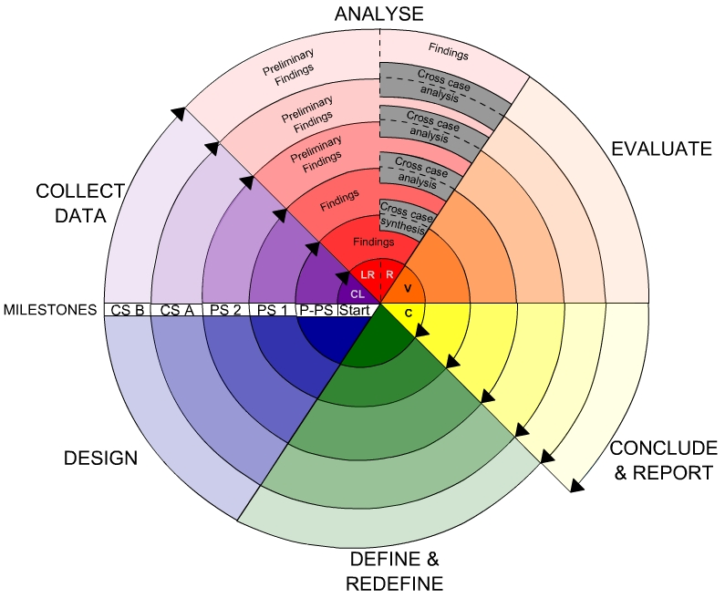
Fig -Spiral Model
Advantages
- High amount of risk analysis
- Good for large and mission-critical projects.
- Software is produced early in the software life cycle.

Existing System:
- Nancy Victor proposed a technique for data compression which enhances the data capability of QR codes by compressing the data previous to creation of QR codes.
- B. Sklar proposed the Reed - Solomon error correction code used for data encryption where one of 4 error correction levels has to be elected during QR code generation.
- R. Villán, S. Voloshynovskiy, O. Koval, F. Deguillaume, and T. Pun proposed the combinati on of strong text hashing and text data hiding technologies as an effective solution to authentication and tamper - proofing of text documents.
- T. V. Bui, N. K. Vu, T. T. P. Nguyen, I. Echizen, and T. D. Nguyen proposed a scheme based on reed - solomon codes and list decoding. Using bit technique, it hides secret information and prevents attacker changing any bit of hidden bits.
- A.E. Dirik, B. Haas discussed a copy detection pattern tool to detect copies from original documents and solely focus o n counterfeit prevention.
- M. Querini, A. Grillo, A. Lentini and G.F. Italiano proposed a high capacity colored two dimensional code (HCC2D) with an intention to increase barcode data density. It supports input data of different types and sizes and code dimension is slickly bespoke to the real input size.
DISADVANTAGES:
- Storage size is high. So it cannot save the storage capacity.
- It cannot restore the private information perfectly.
- While Compression, important information removed.

Proposed System:
- In this system, we propose a two-level QR code. These two levels are public and private level. These levels are used for storage.
- The public level is the same as the standard QR code storage level; therefore, it is readable by any classical QR code application.
- The private level is constructed by replacing the black modules by specific textured patterns. It consists of information encoded using q-ary code with an error correction capacity.
- This allows us not only to increase the storage capacity of the QR code, but also to distinguish the original document from a copy. This authentication is due to the sensitivity of the used patterns to the print-and-scan (P&S) process.
- The pattern recognition method that we use to read the second-level information can be used both in a private message sharing and in an authentication scenario. It is based on maximizing the correlation values between P&S degraded patterns and reference patterns.
- The storage capacity can be significantly improved by increasing the code alphabet q or by increasing the textured pattern size.
ADVANTAGES:
- This proposed technique offers significant enhancement of the data capacity.
- Restoration of private information is perfectly.
- Lossless compression with no information lost.

4.4 Modules Description:

- Public Message Storage
- Private Message Encoding
- Black module replacement
Public Message Storage:
- In this module, the public message is stored in the standard QR code, using the classical generation method. The standard QR code generation algorithm includes the following steps.
- First of all, the most optimal mode (numeric, alphanumeric, byte or Kanji) is selected by analyzing the message content. The message is encoded using the shortest possible string of bits. This string of bits is split up into 8 bit long data codewords. Then, the choice of error correction level is performed and the error correction codewords using the Reed-Solomon code are generated.
- After that, the data and error correction codewords are arranged in the correct order. In order to be sure that the generated QR code can be read correctly, the best (for encoded data) mask pattern is applied.
- After this manipulation, the codewords are placed in a matrix in a zigzag pattern, starting from the bottom-right corner. The final step is to add the function patterns (position tags, alignment, timing, format and version patterns) into the QR code.
Private Message Encoding:
- In this module, the private row-bit string is encoded using error correction code (ECC) to ensure the message error correction after the P&S operation. We use the block codes, and more precisely cyclic codes (or polynomial-generated codes) such as Golay code or Reed-Solomon code, for message encoding.
- The public level is identical to the standard QR code storage level, read by any classical QR code application whereas the private level is made by replacing the black modules by specific textured patterns.
Black Module Replacement:
- In 2LQR code black and white modules are represented using zeros and ones. Cell is divided into 24x24 pixel size.
- Check for zeros and whole of the zeros will be replaced with code. The textured pattern which replaces the black modules is based on the number of zeros available.
- For example, if there are 5 zeros then 5 squares corresponding to that will be drawn while encoding. During decoding the same 5 squares will be decoded as 5.

System Architecture:
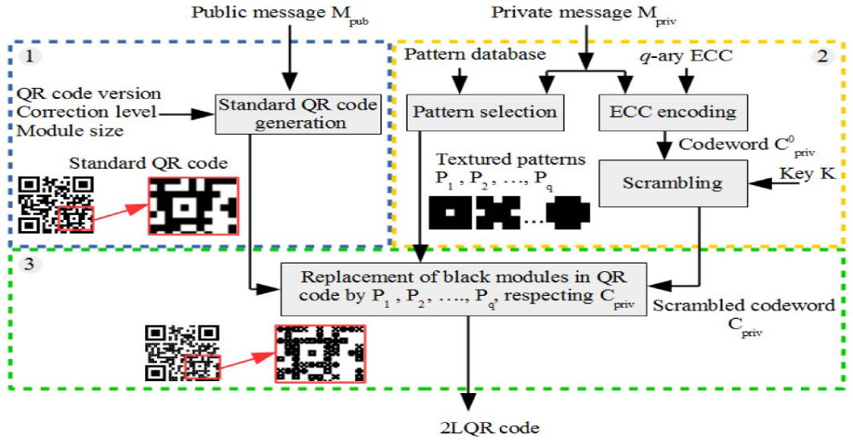

3.5 Feasibility Study
Preliminary investigation examine project feasibility, the likelihood the system will be useful to the organization. The main objective of the feasibility study is to test the Technical, Operational and Economical feasibility for adding new modules and debugging old running system. All system is feasible if they are unlimited resources and infinite time. There are aspects in the feasibility study portion of the preliminary investigation:
- Technical Feasibility
- Operational Feasibility
- Economical Feasibility
3.5.1 Economic Feasibility
A system can be developed technically and that will be used if installed must still be a good investment for the organization. In the economical feasibility, the development cost in creating the system is evaluated against the ultimate benefit derived from the new systems. Financial benefits must equal or exceed the costs.
The system is economically feasible. It does not require any addition hardware or software. Since the interface for this system is developed using the existing resources and technologies available at NIC, There is nominal expenditure and economical feasibility for certain.
3.5.2 Operational Feasibility
Proposed projects are beneficial only if they can be turned out into information system. That will meet the organization’s operating requirements. Operational feasibility aspects of the project are to be taken as an important part of the project implementation. Some of the important issues raised are to test the operational feasibility of a project includes the following: -
- Is there sufficient support for the management from the users?
- Will the system be used and work properly if it is being developed and implemented?
- Will there be any resistance from the user that will undermine the possible application benefits?
This system is targeted to be in accordance with the above-mentioned issues. Beforehand, the management issues and user requirements have been taken into consideration. So there is no question of resistance from the users that can undermine the possible application benefits.
The well-planned design would ensure the optimal utilization of the computer resources and would help in the improvement of performance status.
3.5.3 Technical Feasibility
The technical issue usually raised during the feasibility stage of the investigation includes the following:
- Does the necessary technology exist to do what is suggested?
- Do the proposed equipments have the technical capacity to hold the data required to use the new system?
- Will the proposed system provide adequate response to inquiries, regardless of the number or location of users?
- Can the system be upgraded if developed?
- Are there technical guarantees of accuracy, reliability, ease of access and data security?
Earlier no system existed to cater to the needs of ‘Secure Infrastructure Implementation System’. The current system developed is technically feasible. It is a web based user interface for audit workflow at NIC-CSD. Thus it provides an easy access to the users. The database’s purpose is to create, establish and maintain a workflow among various entities in order to facilitate all concerned users in their various capacities or roles. Permission to the users would be granted based on the roles specified. Therefore, it provides the technical guarantee of accuracy, reliability and security. The software and hard requirements for the development of this project are not many and are already available in-house at NIC or are available as free as open source.

  - System Requirements Specification
5.1 Introduction
A Software Requirements Specification (SRS) – a requirements specification for a software system – is a complete description of the behavior of a system to be developed. It includes a set of use cases that describe all the interactions the users will have with the software. In addition to use cases, the SRS also contains non-functional requirements. Non-functional requirements are requirements which impose constraints on the design or implementation (such as performance engineering requirements, quality standards, or design constraints).
System requirements specification: A structured collection of information that embodies the requirements of a system. A business analyst, sometimes titled system analyst, is responsible for analyzing the business needs of their clients and stakeholders to help identify business problems and propose solutions. Within the systems development life cycle domain, typically performs a liaison function between the business side of an enterprise and the information technology department or external service providers. Projects are subject to three sorts of requirements:
- Business requirements describe in business terms what must be delivered or accomplished to provide value.
- Product requirements describe properties of a system or product (which could be one of
several ways to accomplish a set of business requirements.)
- Process requirements describe activities performed by the developing organization. For instance, process requirements could specify specific methodologies that must be followed, and constraints that the organization must obey.
Product and process requirements are closely linked. Process requirements often specify the activities that will be performed to satisfy a product requirement. For example, a maximum development cost requirement (a process requirement) may be imposed to help achieve a maximum sales price requirement (a product requirement); a requirement that the product be maintainable (a Product requirement) often is addressed by imposing requirements to follow particular development styles

5.2 Purpose
An systems engineering, a requirement can be a description of what a system must do, referred to as a Functional Requirement. This type of requirement specifies something that the delivered system must be able to do. Another type of requirement specifies something about the system itself, and how well it performs its functions. Such requirements are often called Non-functional requirements, or 'performance requirements' or 'quality of service requirements.' Examples of such requirements include usability, availability, reliability, supportability, testability and maintainability.
A collection of requirements define the characteristics or features of the desired system. A 'good' list of requirements as far as possible avoids saying how the system should implement the requirements, leaving such decisions to the system designer. Specifying how the system should be implemented is called "implementation bias" or "solution engineering". However, implementation constraints on the solution may validly be expressed by the future owner, for example for required interfaces to external systems; for interoperability with other systems; and for commonality (e.g. of user interfaces) with other owned products.
In software engineering, the same meanings of requirements apply, except that the focus of interest is the software itself.

5.3 FUNCTIONAL Requirements
The major functional Requirements of the system are as follows
1) Select a Public message store
2) Pass the Name, Birthdates, and Place
3) Generate Standard QR Code
4) Pass the private message apply ECC on it
5) Encoding code word with Texture Patterns
6) Apply print & Scan with Textured Pattern
7) Texture pattern correlation with S1, S2, S3, Min (e1, e2) Vs P1, P2, and P3
8)2LQR Code and apply P&S
9) PS 2LQR Code, Extract Message and Decode
5.4 NON Functional Requirements
The major non-functional Requirements of the system are as follows
Usability
The system is designed with completely automated process hence there is no or less user intervention.
Reliability
The system is more reliable because of the qualities that are inherited from the chosen platform java. The code built by using java is more reliable.

Performance
This system is developing in the high level languages and using the advanced front-end and back-end technologies it will give response to the end user on client system with in very less time.
Supportability
The system is designed to be the cross platform supportable. The system is supported on a wide range of hardware and any software platform, which is having JVM, built into the system.
Implementation
The system is implemented in web environment using struts framework. The apache tomcat is used as the web server and windows xp professional is used as the platform.
Interface the user interface is based on Struts provides HTML Tag

Software Requirements:
Operating System : Windows 7/Windows 8
IDE : Net Beans 8.0/7.3/6.8
Software setup : Jdk8/JDK 7/JDK 6
Technology : Java Standard Edition
Note : As per Operating system setting need to Install JDK (32bit/64 bit)
Based on JDK, select its compatable Netbeans version

Hardware Requirements (Minimum)
Processor : Any Processor above 500 MHz
RAM : 2 GB
Hard Disk : 10 GB
Compact Disk : 650 Mb
Input device : Standard Keyboard and Mouse

6. System Design
6.1 Introduction
The purpose of the design phase is to plan a solution of the problem specified by the requirement document. This phase is the first step in moving from the problem domain to the solution domain. In other words, starting with what is needed, design takes us toward how to satisfy the needs. The design of a system is perhaps the most critical factor affection the quality of the software; it has a major impact on the later phase, particularly testing, maintenance. The output of this phase is the design document. This document is similar to a blueprint for the solution and is used later during implementation, testing and maintenance. The design activity is often divided into two separate phases System Design and Detailed Design.
System Design also called top-level design aims to identify the modules that should be in the system, the specifications of these modules, and how they interact with each other to produce the desired results. At the end of the system design all the major data structures, file formats, output formats, and the major modules in the system and their specifications are decided.
During, Detailed Design, the internal logic of each of the modules specified in system design is decided. During this phase, the details of the data of a module is usually specified in a high-level design description language, which is independent of the target language in which the software will eventually be implemented.
In system design the focus is on identifying the modules, where as during detailed design the focus is on designing the logic for each of the modules. In other works, in system design the attention is on what components are needed, while in detailed design how the components can be implemented in software is the issue.
Design is concerned with identifying software components specifying relationships among components. Specifying software structure and providing blue print for the document phase. Modularity is one of the desirable properties of large systems. It implies that the system is divided into several parts. In such a manner , the interaction between parts is minimal clearly specified.
During the system design activities , Developers bridge the gap between the requirements specification , produced during requirements elicitation and analysis , and the system that is delivered to the user.
Design is the place where the quality is fostered in development . Software design is a process through which requirements are translated into a representation of software.

System Model
Introduction to UML
The unified Modeling Language (UML) is a standard language for writing software blueprints. The UML may be used to visualize, specify , construct and document the artifacts of software-intensive system.
The goal of UML is to provide a standard notation that can be used by all object - oriented methods and to select and integrate the best elements .UML is itself does not prescribe or advice on how to use that notation in a software development process or as part of an object - design methodology. The UML is more than just bunch of graphical symbols. Rather , behind each symbol in the UML notation is well-defined semantics.
The system development focuses on three different models of the system.
- Functional model
- Object model
- Dynamic model
Functional model in UML is represented with use case diagrams , describing the functionality of the system from user point of view.

Object model in UML is represented with class diagrams , describing the structure of the system in terms of objects , attributes , associations and operations.

Dynamic model in UML is represented with sequence diagrams , start chart diagrams and activity diagrams describing the internal behaviour of the system.

6.3 Scenarios
A Use Case is an abstraction that all describes all possible scenarios involving the described functionality . A scenario is an instance of a use case describing a concrete set of actions.
- The name of the scenario enables us to refer it ambiguously. The name of scenario is underlined to indicate it is an instance.
- The Participating actor instance field indicates which actor instance are involved in this scenario. Actor instance also have underlined names.
- The Flow of Events of scenario describe the sequence of events step by step.

6.3.1 Use Case Model
Use case diagrams represent the functionality of the system from a user point of view. A Use case describes a function provided by the system that yields a visible result for an actor. an actor describe any entity that interacts with the system. The identification of actors and use cases results in the definition of the boundary of the system, which is , in differentiating the tasks accomplished by the system and the tasks accomplished by its environment. The actors outside the boundary of the system, where as the use cases are inside the boundary of the system
A Use case contains all the events that can occur between an actor and a set of scenarios that explains the interactions as sequence of happenings.

Actors
Actors represent external entities that interact with the system. An actor can be human or external system.
Actor are not part of the system. They represent anyone or anything that interact with the system.
An Actor may
- Only input information to the system.
- Only receive information from the system.
- Input and receive information from to and from the system.
During this activity , developers indentify the actors involved in this system are:

User:
User is an actor who uses the system and who performs the operations like data classifications and execution performance that are required for him.

Use Cases:

What is a UML Use Case Diagram?
Use case diagrams model the functionality of a system using actors and use cases. Use cases are services or functions provided by the system to its users.

Basic Use Case Diagram Symbols and Notations

System
Draw your system's boundaries using a rectangle that contains use cases. Place actors outside the system's boundaries.
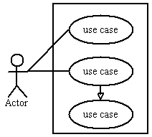

Use Case
Draw use cases using ovals. Label with ovals with verbs that represent the system's functions.
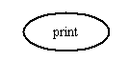

Actors
Actors are the users of a system. When one system is the actor of another system, label the actor system with the actor stereotype.
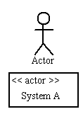

Relationships
Illustrate relationships between an actor and a use case with a simple line. For relationships among use cases, use arrows labeled either "uses" or "extends." A "uses" relationship indicates that one use case is needed by another in order to perform a task. An "extends" relationship indicates alternative options under a certain use case.
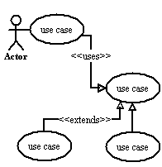

Class Diagram

What is a UML Class Diagram?
Class diagrams are the backbone of almost every object-oriented method including UML. They describe the static structure of a system.

Basic Class Diagram Symbols and Notations
Classes represent an abstraction of entities with common characteristics. Associations represent the relationships between classes.
Illustrate classes with rectangles divided into compartments. Place the name of the class in the first partition (centered, bolded, and capitalized), list the attributes in the second partition, and write operations into the third.
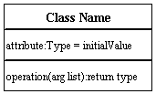

Active Class
Active classes initiate and control the flow of activity, while passive classes store data and serve other classes. Illustrate active classes with a thicker border.
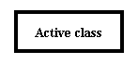

Visibility
Use visibility markers to signify who can access the information contained within a class. Private visibility hides information from anything outside the class partition. Public visibility allows all other classes to view the marked information. Protected visibility allows child classes to access information they inherited from a parent class. .
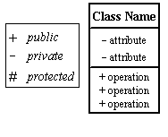

Associations
Associations represent static relationships between classes. Place association names above, on, or below the association line. Use a filled arrow to indicate the direction of the relationship. Place roles near the end of an association. Roles represent the way the two classes see each other.
Note: It's uncommon to name both the association and the class roles.
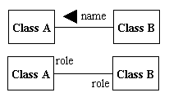

Multiplicity (Cardinality)
Place multiplicity notations near the ends of an association. These symbols indicate the number of instances of one class linked to one instance of the other class. For example, one company will have one or more employees, but each employee works for one company only.
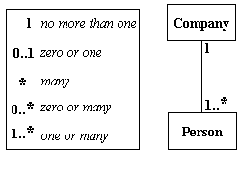

Constraint
Place constraints inside curly braces {}.
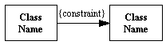Simple Constraint 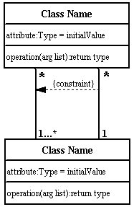

Composition and Aggregation
Composition is a special type of aggregation that denotes a strong ownership between Class A, the whole, and Class B, its part. Illustrate composition with a filled diamond. Use a hollow diamond to represent a simple aggregation relationship, in which the "whole" class plays a more important role than the "part" class, but the two classes are not dependent on each other. The diamond end in both a composition and aggregation relationship points toward the "whole" class or the aggregate
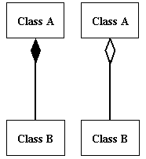

Generalization
Generalization is another name for inheritance or an "is a" relationship. It refers to a relationship between two classes where one class is a specialized version of another. For example, Honda is a type of car. So the class Honda would have a generalization relationship with the class car.
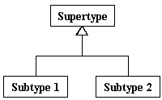
In real life coding examples, the difference between inheritance and aggregation can be confusing. If you have an aggregation relationship, the aggregate (the whole) can access only the PUBLIC functions of the part class. On the other hand, inheritance allows the inheriting class to access both the PUBLIC and PROTECTED functions of the super class.
6.3.3 Dynamic model:

Sequence Diagram
Sequence diagrams describe interactions among classes in terms of an exchange of messages over time.

Basic Sequence Diagram Symbols and Notations

Class roles
Class roles describe the way an object will behave in context. Use the UML object symbol to illustrate class roles, but don't list object attributes.
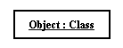

Activation
Activation boxes represent the time an object needs to complete a task.
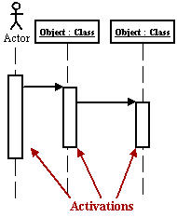

Messages
Messages are arrows that represent communication between objects. Use half-arrowed lines to represent asynchronous messages. Asynchronous messages are sent from an object that will not wait for a response from the receiver before continuing its tasks.
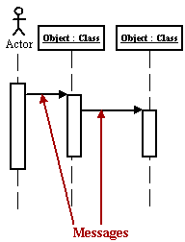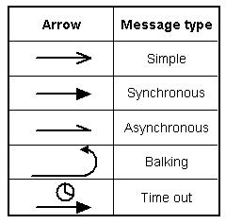
Various message types for Sequence and Collaboration diagrams

Lifelines
Lifelines are vertical dashed lines that indicate the object's presence over time.
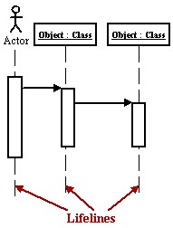

Destroying Objects
Objects can be terminated early using an arrow labeled "<< destroy >>" that points to an X.
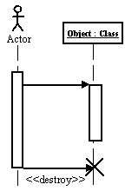

Loops
A repetition or loop within a sequence diagram is depicted as a rectangle. Place the condition for exiting the loop at the bottom left corner in square brackets [ ].
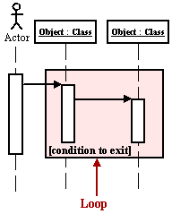

State chart Diagram
A state chart diagram shows the behavior of classes in response to external stimuli. This diagram models the dynamic flow of control from state to state within a system.

Basic State chart Diagram Symbols and Notations

States
States represent situations during the life of an object. You can easily illustrate a state in Smart Draw by using a rectangle with rounded corners.
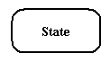

Transition
A solid arrow represents the path between different states of an object. Label the transition with the event that triggered it and the action that results from it.
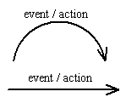

Initial State
A filled circle followed by an arrow represents the object's initial state.
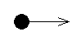

Final State
An arrow pointing to a filled circle nested inside another circle represents the object's final state.
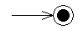

Synchronization and Splitting of Control
A short heavy bar with two transitions entering it represents a synchronization of control. A short heavy bar with two transitions leaving it represents a splitting of control that creates multiple states.
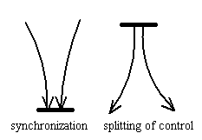
Activity Diagram
An activity diagram illustrates the dynamic nature of a system by modeling the flow of control from activity to activity. An activity represents an operation on some class in the system that results in a change in the state of the system. Typically, activity diagrams are used to model workflow or business processes and internal operation. Because an activity diagram is a special kind of state chart diagram, it uses some of the same modeling conventions.

Basic Activity Diagram Symbols and NotationsAction states
Action states represent the non interruptible actions of objects. You can draw an action state in Smart Draw using a rectangle with rounded corners.
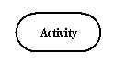

Action Flow
Action flow arrows illustrate the relationships among action states.
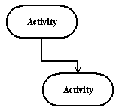

Object Flow
Object flow refers to the creation and modification of objects by activities. An object flow arrow from an action to an object means that the action creates or influences the object. An object flow arrow from an object to an action indicates that the action state uses the object.
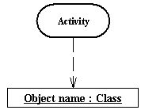

Initial State
A filled circle followed by an arrow represents the initial action state.

Final State
An arrow pointing to a filled circle nested inside another circle represents the final action state.

Branching
A diamond represents a decision with alternate paths. The outgoing alternates should be labeled with a condition or guard expression. You can also label one of the paths "else."
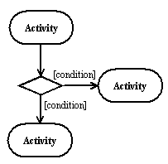

Synchronization
A synchronization bar helps illustrate parallel transitions. Synchronization is also called forking and joining.
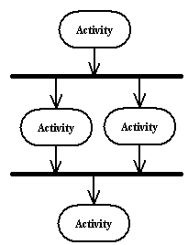

Swimlanes
Swimlanes group related activities into one column.
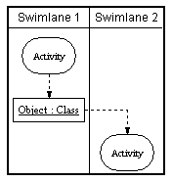

Introduction to UML
The unified Modeling Language (UML) is a standard language for writing software blueprints. The UML may be used to visualize, specify , construct and document the artifacts of software-intensive system.
The goal of UML is to provide a standard notation that can be used by all object - oriented methods and to select and integrate the best elements .UML is itself does not prescribe or advice on how to use that notation in a software development process or as part of an object - design methodology. The UML is more than just bunch of graphical symbols. Rather , behind each symbol in the UML notation is well-defined semantics.
The system development focuses on three different models of the system.
- Functional model
- Object model
- Dynamic model
Functional model in UML is represented with use case diagrams , describing the functionality of the system from user point of view.

Object model in UML is represented with class diagrams , describing the structure of the system in terms of objects , attributes , associations and operations.

Dynamic model in UML is represented with sequence diagrams , start chart diagrams and activity diagrams describing the internal behaviour of the system.

6.3 Scenarios
A Use Case is an abstraction that all describes all possible scenarios involving the described functionality . A scenario is an instance of a use case describing a concrete set of actions.
- The name of the scenario enables us to refer it ambiguously. The name of scenario is underlined to indicate it is an instance.
- The Participating actor instance field indicates which actor instance are involved in this scenario. Actor instance also have underlined names.
- The Flow of Events of scenario describe the sequence of events step by step.

6.3.1 Use Case Model
Use case diagrams represent the functionality of the system from a user point of view. A Use case describes a function provided by the system that yields a visible result for an actor. an actor describe any entity that interacts with the system. The identification of actors and use cases results in the definition of the boundary of the system, which is , in differentiating the tasks accomplished by the system and the tasks accomplished by its environment. The actors outside the boundary of the system, where as the use cases are inside the boundary of the system
A Use case contains all the events that can occur between an actor and a set of scenarios that explains the interactions as sequence of happenings.

Actors
Actors represent external entities that interact with the system. An actor can be human or external system.
Actor are not part of the system. They represent anyone or anything that interact with the system.
An Actor may
- Only input information to the system.
- Only receive information from the system.
- Input and receive information from to and from the system.
During this activity , developers indentify the actors involved in this system are:

User:
User is an actor who uses the system and who performs the operations like data classifications and execution performance that are required for him.

Use Cases:
Use cases are used during requirements elicitation and analysis to represent the functionality of the system. Use case focus on the behaviour of the system from an external point of view. The identification of actors and use cases results in the definition of the boundary of the system , which is , in differentiating the tasks accomplished by the system and the tasks accomplished by its environment. The actors are outside the boundary of the system , where as the use cases are inside the boundary of the system.

Use case diagram
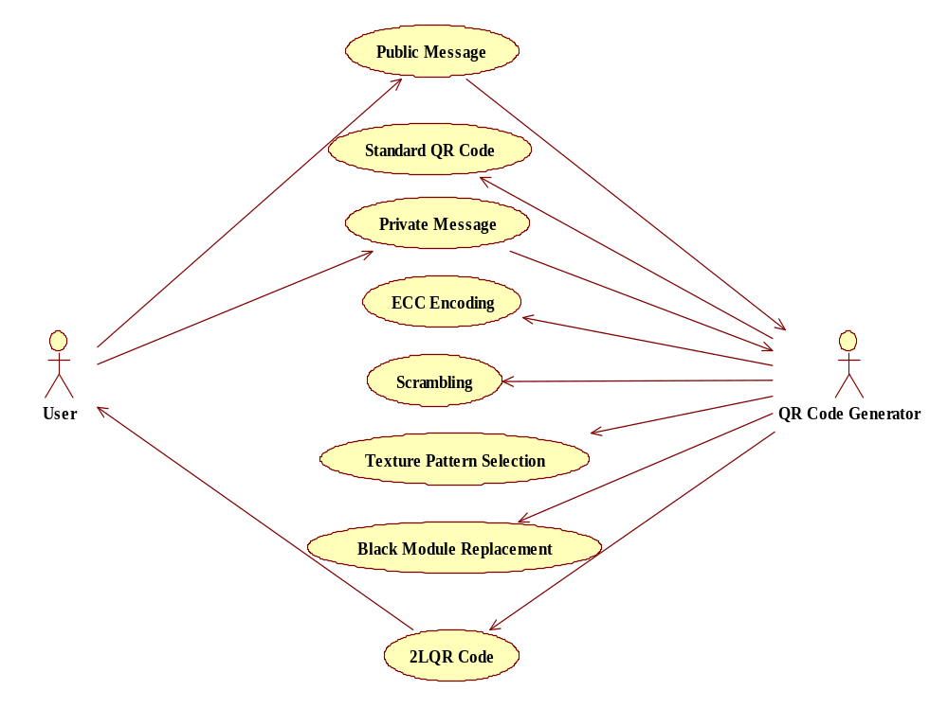

6.3.2 Object model

Class Diagram
Class Diagrams are used to describe the structure of the system. Classes are abstractions that specify the common structure and behaviour of a set of objects. Objects are instances of classes that are created , modified and destroyed during the execution of a system. An object has state that includes the values of its attributes and links with other objects.
The class diagram is used to refine the use cases diagrams and define a detailed design of the system. The class diagram classifies the actors defined in the use case diagram into a set of interrelated classes. The relationship or association between the classes can be either an "is-a" or "has-a" relationship. Each class in the class diagram may be capable of providing certain functionalities. These functionalities provided by the class are termed "methods" of the classes. Apart from this , each class may have certain "attributes" that uniquely indentify the class. In the class diagram these classes are represented with boxes which contain three parts..
Class Diagram
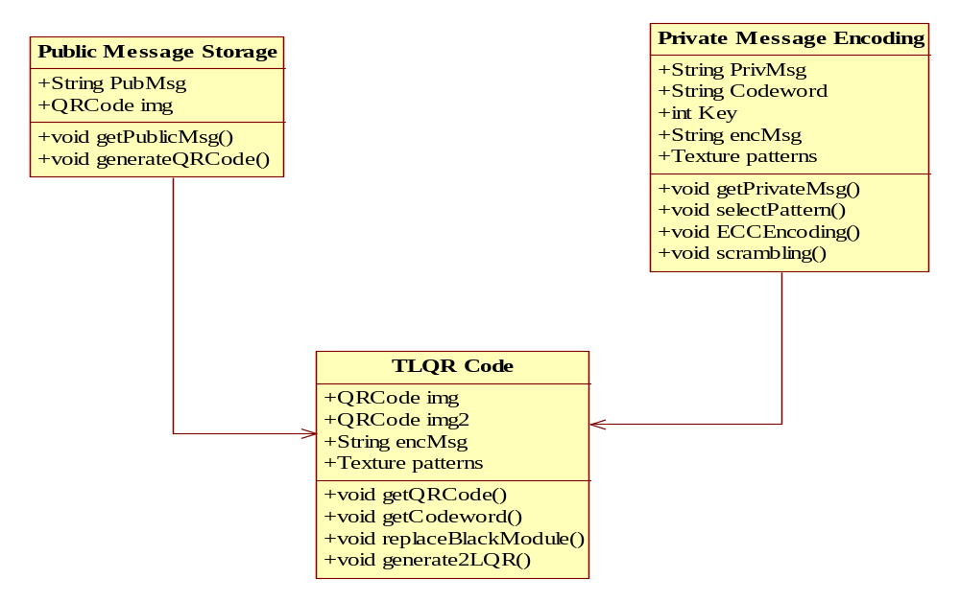
Fig: Class diagram

Object Diagram:
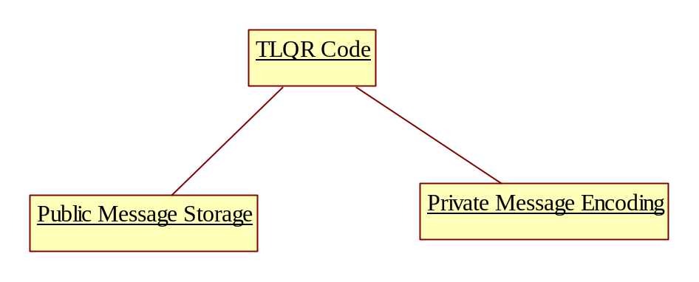

6.3.3 Dynamic model
6.3.3.1 Sequence Diagram
Sequence diagrams are used to formalize the dynamic behaviour of the system and to visualize the communication among the objects. They are useful for identifying the additional objects that participate in the use case. Sequence diagram represent the objects participating in the interaction horizontally and time vertically.
Sequence diagrams typically show a user or actor and the objects and the components they interact with the execution of the use case. Each column represents an objects that participate in the interaction. Message is shown by solid arrows. Labels on the solid arrows represent the message names. Activations are depicted by vertical rectangles. The actor who initiates the interaction is shown in the left most columns. The messages coming from the actor represent the interactions described in the use case diagrams.
Sequence diagram:
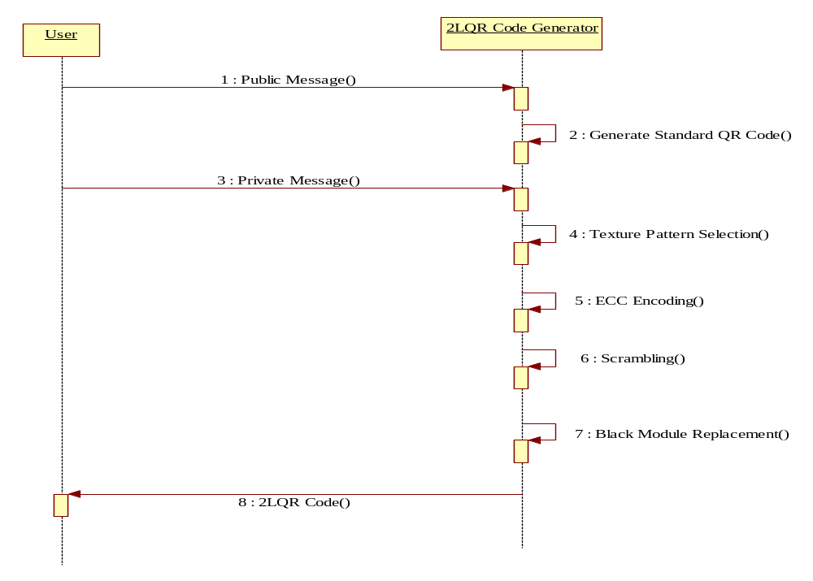
Fig: Sequence diagram
Collaboration Diagram
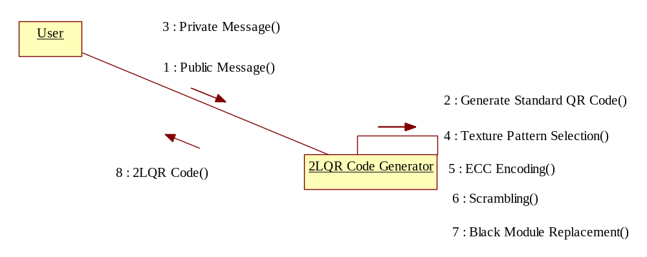
Fig: Collaboration diagram

6.3.3.2 State Chart Diagram
UML State chart is notation for describing the sequence of states an object goes through in response to external events. Objects have behavior and state. The state of an object depends on its current activity or condition. A state chart diagram shows the possible states of the object ad the transitions that cause a change in state.
State chart describes the dynamic behavior of an individual object as a number of states. A state is a condition satisfied by attributes of objects. Given a state , a transition represents a future state the object can move to and the conditions associated with the change of state.
A state is depicted by a rounded rectangle A transition is depicted by open arrows connecting two states. States are labeled with their names. A small solid black circle indicates the initial state and a circle surrounding the small solid circle indicates the final state.
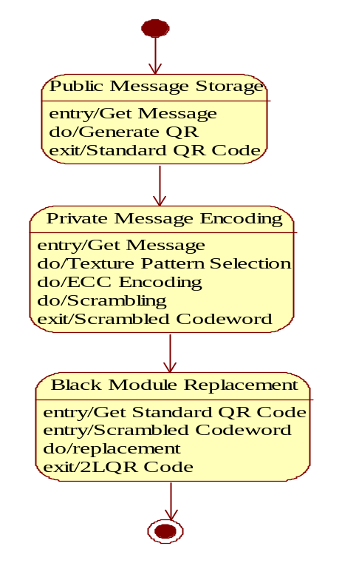

6.3.3.3 Activity Diagram
An Activity diagram describes the behaviour of the system in terms of activities. Activities are modeling elements that represent the execution of set of operations. The completion of these operations triggers a transition to another activity. Activity diagrams similar to flowchart diagrams in that they can be used to represent control flow and data flow . Activities are represented by rounded rectangles and arrows are represented transition between activities . Think bars represent the synchronization of the control flow.
ACTIVITY DIAGRAM:
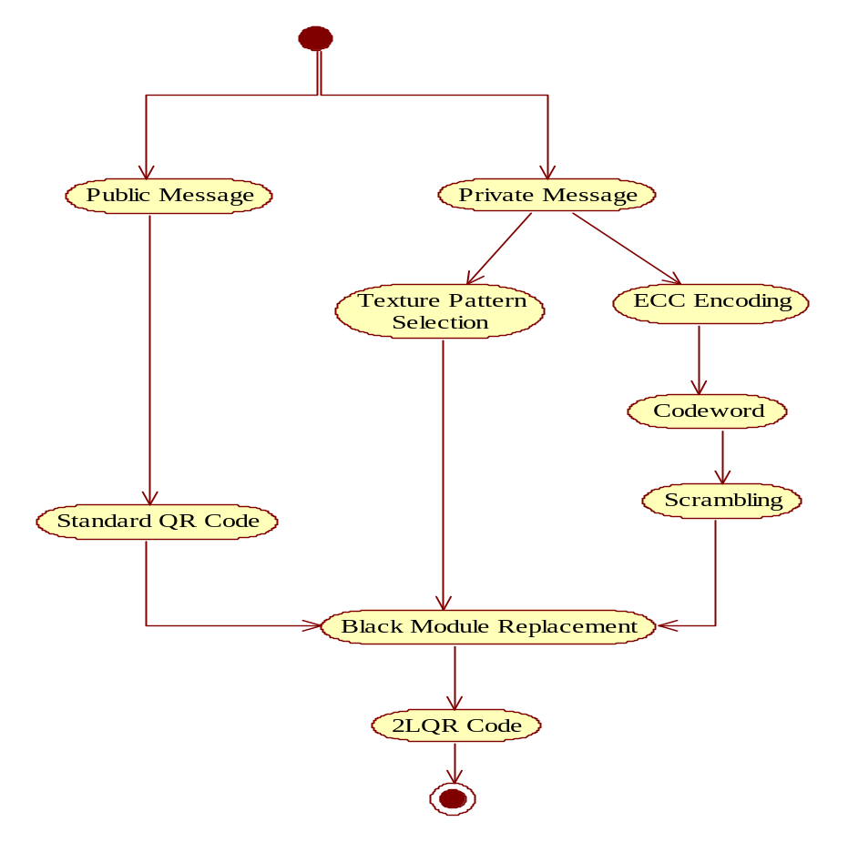

Fig: Activity Diagram

Component Diagram:

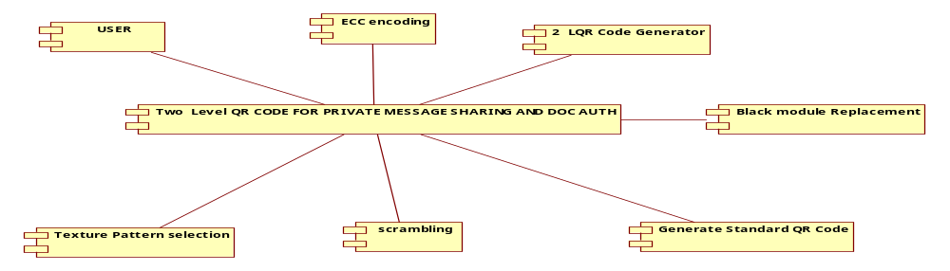
Fig : Component diagram
Deployment diagram:

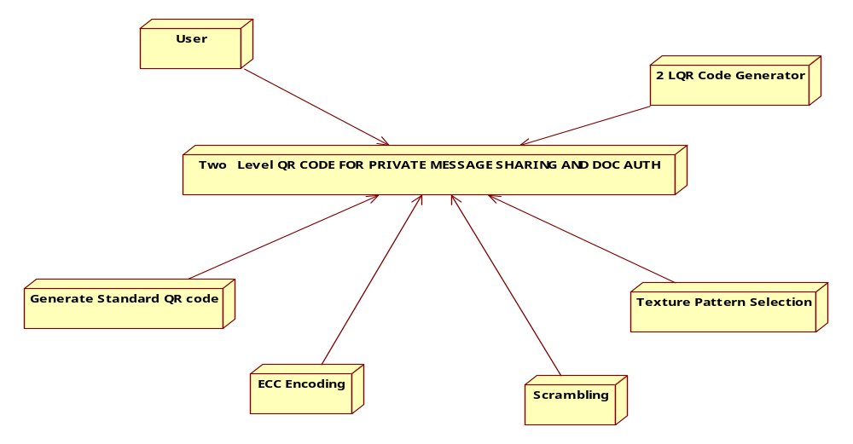

Fig : Deployment diagram

Data Flow Diagrams( c)
A graphical tool used to describe and analyze the moment of data through a system manual or automated including the process, stores of data, and delays in the system. Data Flow Diagrams are the central tool and the basis from which other components are developed. The transformation of data from input to output, through processes, may be described logically and independently of the physical components associated with the system. The DFD is also know as a data flow graph or a bubble chart.
DFDs are the model of the proposed system. They clearly should show the requirements on which the new system should be built. Later during design activity this is taken as the basis for drawing the system’s structure charts. The Basic Notation used to create a DFD’s are as follows:
1. Dataflow: Data move in a specific direction from an origin to a destination.

2. Process: People, procedures, or devices that use or produce (Transform) Data. The physical component is not identified.

3. Source: External sources or destination of data, which may be People, programs, organizations or other entities.

4. Data Store: Here data are stored or referenced by a process in the System.

DFD:
Code Generation
Message
2LQR Code

Public Message Storage
Private Message Encoding
Message
Secret Data
Black Module Replacement

Public Message Storage
Standard QR Code Generation
Message
2LQR Code
Private Message Encoding
Texture Pattern Selection

ECC Coding

Scrambling
Black Module Replacement

7. Implementation
7.1 Introduction
Implementation is the stage where the theoretical design is turned in to working system. The most crucial stage is achieving a new successful system and in giving confidence on the new system for the users that it will work efficiently and effectively.
The system can be implemented only after through testing is done and if it found to work according to the specification. It involves careful planning, investigation of the current system and its constraints on implementation, design of methods to achieve the change over and an evaluation of change over methods a part from planning. Two major tasks of preparing the implementation are education and training of the users and testing of the system.
The more complex the system being implemented, the more involved will be the systems analysis and design effort required just for implementation. The implementation phase comprises of several activities. The required hardware and software acquisition is carried out. The System may require some hardware and software acquisition is carried out. The system may require some software to be developed. For this, programs are written and tested. The user then changes over to his new fully tested system and the old system is discontinued.
Implementation is the process of having systems personnel check out and put new equipment in to use, train users, install the new application, and construct any files of data needed to it.
Depending on the size of the organization that will be involved in using the application and the risk associated with its use, system developers may choose to test the operation in only one area of the firm, say in one department or with only one or two persons. Sometimes they will run the old and new systems together to compare the results. In still other situations, developers will stop using the old system one-day and begin using the new one the next. As we will see, each implementation strategy has its merits, depending on the business situation in which it is considered. Regardless of the implementation strategy used, developers strive to ensure that the system’s initial use in trouble-free.

About the Java Technology
The Java platform consists of the Java application programming interfaces (APIs) and the Java virtual machine (JVM).

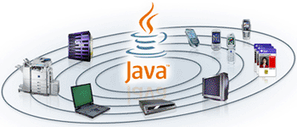
The following Java technology lets developers, designers, and business partners develop and deliver a consistent user experience, with one environment for applications on mobile and embedded devices. Java meshes the power of a rich stack with the ability to deliver customized experiences across such devices.
Java APIs are libraries of compiled code that you can use in your programs. They let you add ready-made and customizable functionality to save you programming time.
Java programs are run (or interpreted) by another program called the Java Virtual Machine. Rather than running directly on the native operating system, the program is interpreted by the Java VM for the native operating system. This means that any computer system with the Java VM installed can run Java programs regardless of the computer system on which the applications were originally developed.

In the Java programming language, all source code is first written in plain text files ending with the .java extension. Those source files are then compiled into .class files by the javac compiler. A .class file does not contain code that is native to your processor; it instead contains bytecodes — the machine language of the Java Virtual Machine (Java VM). The java launcher tool then runs your application with an instance of the Java Virtual Machine.

Because the Java VM is available on many different operating systems, the same .class files are capable of running on Microsoft Windows, the Solaris TM Operating System (Solaris OS), Linux, or Mac OS.
Java technology is both a programming language and a platform.

The Java Programming Language
The Java programming language is a high-level language that can be characterized by all of the following buzzwords:
- Simple  - Object oriented  - Distributed  - Multithreaded  - Dynamic | - Architecture neutral  - Portable  - High performance  - Robust  - Secure
Each of the preceding buzzwords is explained in The Java Language Environment , a white paper written by James Gosling and Henry McGilton.
In the Java programming language, all source code is first written in plain text files ending with the .java extension. Those source files are then compiled into .class files by the javac compiler. A .class file does not contain code that is native to your processor; it instead contains bytecodes — the machine language of the Java Virtual Machine¹ (Java VM). The java launcher tool then runs your application with an instance of the Java Virtual Machine.
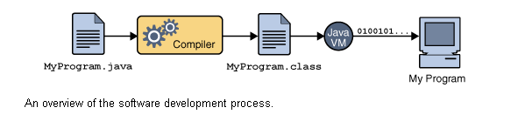
An overview of the software development process.
Because the Java VM is available on many different operating systems, the same .class files are capable of running on Microsoft Windows, the Solaris™ Operating System (Solaris OS), Linux, or Mac OS. Some virtual machines, such as the Java HotSpot virtual machine, perform additional steps at runtime to give your application a performance boost. This include various tasks such as finding performance bottlenecks and recompiling (to native code) frequently used sections of code

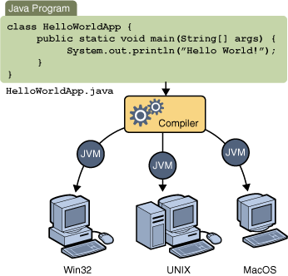
Through the Java VM, the same application is capable of running on multiple platforms.
AWT
AWT is the acronym of Abstract Window Toolkit.
Introduction:
GUI (Graphical User Interface) is a mediator (translator) between the end user and the program.
Form : It is a collection of GUIs designed for one specific purpose.
* Console is a program, provided by the local OS, which supports only text output.
* In order to display GUI outputs, we have another program (similar to the console) provided by the local os. This program is, window.
* All the java classes, which are used to create GUIs are present in the package java.awt.
* The theory behind the creation of GUIs is as follows.
* The functionality of the constructor of the class, whose GUI is to be created, is to create that particular GUI.
* Strictly speaking, this is not the functionality of the constructor of that class.
* In fact, the constructor has some statements which are nothing but, a call to a specific file in the local os. This particular file will be responsible in creating the corresponding GUI. In the foreground, it seems as if the GUI is created just because of the constructor.
* Whatever language we use to create the GUIs, (for example : java, html, vb e.t.c.) in all these cases, only the files present in the local os will be responsible for creating the corresponding GUIs.
* Because of this, the GUIs created in all these cases will look alike.
* Let us take java in particular.
* When we want to create a GUI, we need to create object of that class which represents the corresponding GUI. Let us assume we need to create a GUI – a button. Then we need to write the following code, i.e.
* Button b1 = new Button ();
* So, to create the button GUI, JVM executes the constructor of the Button class. Inside the constructor we have statements which execute the files present in the local os to create the GUI.
* The means, we are making JVM to execute the files present in the local operating system.
* But remember that, JVM can execute only byte code, which is generated from the .class file and this .class file is results from a .java file.
* The files present in the local operating system need not be in java and definitely they will not be in java.
* They will be in some other native language.
Question : Then, how can JVM execute the files present in the local os to create the GUIs?
Ans: JVM depends upon some classes known as Peer Classes to execute the files present in the local os.
* Thus, every awt component depends upon the files of the local os to create GUIs, making JVM to execute those files which are non-java files. This increases the overhead on the JVM. This is the reason why we call awt classes (components) as heavy-weight components
* From the above discussion, it is clear that each os will have its own files for creating the GUIs.
* Now, if we create a GUI using java on one os, then the look and feel of this GUI will be completely different when we execute the same java program on another OS.
Question: Java is not purely platform independent. Justify.
Ans: Because of the dependency of awt programs on the local os in creating GUIs, the outputs of these programs very from one os to another os. i.e. the outputs of the awt programs are platform dependent. This makes java to be platform-dependent.
This is the reason, why we say that java is not purely platform-independent.
Disadvantages of AWT :
(i) The AWT programs increase the overhead on the JVM.
(ii) The make java to be platform dependent.
* The above disadvantages are over-come in Swings
* Swings is an extension of AWT. The swing components do not depend upon the files of the local os in creating the GUIs and thereby, they decrease the overhead on the JVM.
* Thus, swings are known as Light-Weight Components.
* The following is the class hierarchy of java.awt package.
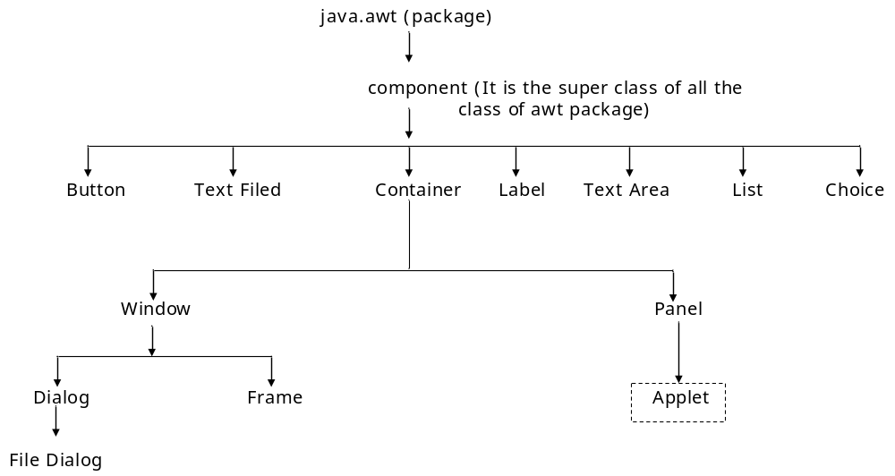
NOTE: Applet class does not belong to java.awt package.
* Applet class belongs to java. applet package.
* We know that window is used for displaying the GUIs.
* A blind rule is that, when we want to add a component to another component then the later component should have the properties of a container.
* Whenever we want to view a GUI output, we add all the required components to the window and then they are displayed that means, window has the properties of a container.
* From the class hierarchy, it is clear that window is the sub class of container class. Hence it has all the properties of a container.
* If we want to add a Button to another button, it is not possible because, button is not a sub class of container and it does not have the properties of a container.
* Same is the case with the other classes present in that level of hierarchy.
* Similarly, we can not think of adding Text Filed to a Label, Text Area to a List e.t.c.
* Thus, any component which has the properties of container is eligible to accommodate other components in it.
* It is clear from the class hierarchy that panel is a sub-class of container and window is at the same level of hierarchy.
* Panel has the properties of container and any no. of components can be added to the panel. To make them visible on the screen, we again need window, but observe that panel does not have the properties of a window.
* Therefore, panel should be added to the window to make the components visible.
* Similarly, we can create a Frame. Frame has the properties of window as well as container
* As Button, Text Area e.t.c. have some properties, window also has some properties.
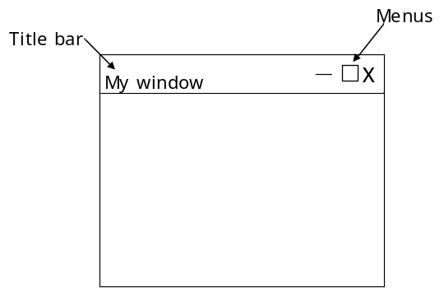
- It has a title-bar
- It has some system Menus
- We should be able to drag it
- We should be able to resize it e.t.c.
* Some of the best examples of the window application are Edit plus Editor, Notepad, IE browser e.t.c.
NOTE: As console cannot display GUIs, window cannot display text directly.
* In order to display text on the window, we need to represent the text in the form of a GUI component and then add it to the window. For this, we make use of the Label class.
* We always prefer to create a window through Frame because window alone has no feature of boundaries. The facility of having boundaries for a window is possible with Frame. This is the reason why we create window through Frame.
* Using the functions of the Frame class we can set the dimensions (size) for the window.
Using Java in Oracle Database
are assembled as data queries for immediate processing, and query results are generated on the fly. Several features make Java ideal for server programming. Java lets you assemble applications using off-the-shelf software components, such as JavaBeans. Its type safety and automatic memory management allow for tight integration with the database. In addition, Java supports the transparent distribution of application components across a network. Java and Oracle Database support the rapid assembly of component-based, network-centric applications that can evolve gracefully as business needs change. In addition, you can move applications and data stores off the desktop and onto intelligent networks and network-centric servers. More important, you can access those applications and data stores from any client device. Figure 1–5 shows a traditional two-tier, client/server configuration in which clients call Java stored procedures the same way they call PL/SQL stored procedures. The figure also shows how the Oracle Net Services Connection Manager can combine many network connections into a single database connection. This enables Oracle Database to support a large number of concurrent users.

8. System Testing
- SYSTEM TESTING
  - Introduction
Software testing is any activity aimed at evaluating an attribute or capability of a program or system and determining that it meets its required results. Although crucial to software quality and widely deployed by programmers and testers, software testing still remains an art, due to limited understanding of the principles of software. The difficulty in software testing stems from the complexity of software. Testing is more than just debugging. The purpose of testing can be quality assurance, verification and validation, or reliability estimation. Testing can be used as a generic metric as well. Correctness testing and reliability testing are two major areas of testing. Software testing is a trade-off between budget, time and quality.
Software Testing is the process of executing a program or system with the intent of finding errors. Software is not unlike other physical processes where inputs are received and outputs are produced. Where software differs is in the manner in which it fails. Most physical systems fail in a fixed (and reasonably small) set of ways. By contrast, software can fail in many bizarre ways. Detecting all of the different failure modes for software is generally infeasible. Unlike most physical systems, most of the defects in software are design errors, not manufacturing defects. Software does not suffer from corrosion, wear-and-tear, generally it will not change until upgrades, or until obsolescence. So once the software is shipped, the design defects or bugs will be buried in and remain latent until activation.
Software bugs will almost always exist in any software module with moderate size: not because programmers are careless or irresponsible, but because the complexity of software is generally intractable and humans have only limited ability to manage complexity. It is also true that for any complex systems, design defects can never be completely ruled out.
Discovering the design defects in software is equally difficult, for the same reason of complexity. Because software and any digital systems are not continuous, testing boundary values are not sufficient to guarantee correctness. All the possible values need to be tested and verified, but complete testing is infeasible. Exhaustively testing a simple program to add only two integer inputs of 32-bits (yielding 2^64 distinct test cases) would take hundreds of years, even if tests were performed at a rate of thousands per second. Obviously, for a realistic software module, the complexity can be far beyond the example mentioned here. If inputs from the real world are involved, the problem will get worse, because timing and unpredictable environmental effects and human interactions are all possible input parameters under consideration.
A further complication has to do with the dynamic nature of programs. If a failure occurs during preliminary testing and the code is changed, the software may now work for a test case that it didn't work for previously. But its behavior on pre-error test cases that it passed before can no longer be guaranteed. To account for this possibility, testing should be restarted. The expense of doing this is often prohibitive.
Regardless of the limitations, testing is an integral part in software development. It is broadly deployed in every phase in the software development cycle. Typically, more than 50% percent of the development time is spent in testing. Testing is usually performed for the following purposes:
- To improve quality
As computers and software are used in critical applications, the outcome of a bug can be severe. Bugs can cause huge losses. Bugs in critical systems have caused airplane crashes, allowed space shuttle missions to go awry, halted trading on the stock market, and worse. Bugs can kill. Bugs can cause disasters. The so-called year 2000 (Y2K) bug has given birth to a cottage industry of consultants and programming tools dedicated to making sure the modern world doesn't come to a screeching halt on the first day of the next century. In a computerized embedded world, the quality and reliability of software is a matter of life and death.
Quality means the conformance to the specified design requirement. Being correct, the minimum requirement of quality, means performing as required under specified circumstances. Debugging, a narrow view of software testing, is performed heavily to find out design defects by the programmer. The imperfection of human nature makes it almost impossible to make a moderately complex program correct the first time. Finding the problems and get them fixed is the purpose of debugging in programming phase.
- For Verification & Validation (V&V)
Just as topic Verification and Validation indicated, another important purpose of testing is verification and validation (V&V). Testing can serve as metrics. It is heavily used as a tool in the V&V process. Testers can make claims based on interpretations of the testing results, which either the product works under certain situations, or it does not work. We can also compare the quality among different products under the same specification, based on results from the same test.
We cannot test quality directly, but we can test related factors to make quality visible. Quality has three sets of factors- functionality, engineering, and adaptability. These three sets of factors can be thought of as dimensions in the software quality space. Each dimension may be broken down into its component factors and considerations at successively lower levels of detail.
- For reliability estimation
Software reliability has important relations with many aspects of software, including the structure, and the amount of testing it has been subjected to. Based on an operational profile, testing can serve as a statistical sampling method to gain failure data for reliability estimation.
  - Testing Methods

Unit testing:
Unit testing involves the design of test cases that validate that the internal program logic is functioning properly, and that program input produces valid outputs. All decision branches and internal code flow should be validated. It is the testing of individual software units of the application. It is done after the completion of an individual unit before integration. This is a structural testing, that relies on knowledge of its construction and is invasive. Unit tests perform basic tests at component level and test a specific business process, application, and/or system configuration. Unit tests ensure that each unique path of a business process performs accurately to the documented specifications and contains clearly defined inputs and expected results.

Integration testing:
Integration tests are designed to test integrated software components to determine if they actually run as one program. Testing is event driven and is more concerned with the basic outcome of screens or fields. Integration tests demonstrate that although the components were individually satisfaction, as shown by successfully unit testing, the combination of components is correct and consistent. Integration testing is specifically aimed at exposing the problems that arise from the combination of components.

Functional testing:

Functional tests provide systematic demonstrations that functions tested are available as specified by the business and technical requirements, system documentation, and user manuals.
Functional testing is centered on the following items:
Valid Input : identified classes of valid input must be accepted.
Invalid Input : identified classes of invalid input must be rejected.
Functions : identified functions must be exercised.
Output : identified classes of application outputs must be exercised.
Systems/Procedures : interfacing systems or procedures must be invoked.
Organization and preparation of functional tests is focused on requirements, key functions, or special test cases. In addition, systematic coverage pertaining to identify Business process flows; data fields, predefined processes, and successive processes must be considered for testing. Before functional testing is complete, additional tests are identified and the effective value of current tests is determined.

System Testing:
System testing ensures that the entire integrated software system meets requirements. It tests a configuration to ensure known and predictable results. An example of system testing is the configuration oriented system integration test. System testing is based on process descriptions and flows, emphasizing pre-driven process links and integration points.

White Box Testing:
White Box Testing is a testing in which in which the software tester has knowledge of the inner workings, structure and language of the software, or at least its purpose. It is purpose. It is used to test areas that cannot be reached from a black box level.

Black Box Testing:
Black Box Testing is testing the software without any knowledge of the inner workings, structure or language of the module being tested. Black box tests, as most other kinds of tests, must be written from a definitive source document, such as specification or requirements document, such as specification or requirements document. It is a testing in which the software under test is treated, as a black box .you cannot “see” into it. The test provides inputs and responds to outputs without considering how the software works.

Acceptance Testing
It is a pre-delivery testing in which entire system is tested at client's site on real world data to find errors.

Test Approach
Testing can be done in two ways
- Bottom up approach
- Top down approach
Bottom up Approach
Testing can be performed starting from smallest and lowest level modules and proceeding one at a time. For each module in bottom up testing a short program executes the module and provides the needed data so that the module is asked to perform the way it will when embedded within the larger system. When bottom level modules are tested attention turns to those on the next level that use the lower level ones they are tested individually and then linked with the previously examined lower level modules.
Top down approach
This type of testing starts from upper level modules. Since the detailed activities usually performed in the lower level routines are not provided stubs are written. A stub is a module shell called by upper level module and that when reached properly will return a message to the calling module indicating that proper interaction occurred. No attempt is made to verify the correctness of the lower level module.
Validation
The system has been tested and implemented successfully and thus ensured that all the requirements as listed in the software requirements specification are completely fulfilled. In case of erroneous input corresponding error messages are displayed.

  - Test Cases
In general a test case is a set of test data and test programs and their expected results. A test case in software engineering normally consists of a unique identifier, requirement references from a design specification, preconditions, events, a series of steps (also known as actions) to follow, input, output and it validates one or more system requirements and generates a pass or fail.
The mechanism for determining whether a software program or system has passed or failed such a test is known as a test oracle. In some settings, an oracle could be a requirement or use case, while in others it could be a heuristic. It may take many test cases to determine that a software program or system is considered sufficiently scrutinized to be released. Test cases are often referred to as test scripts, particularly when written. Written test cases are usually collected into test suites. If a requirement has sub-requirements, each sub-requirement must have at least two test cases. Written test cases should include a description of the functionality to be tested, and the preparation required to ensure that the test can be conducted.
The purpose of testing is to discover errors. Testing is the process of trying to discover every conceivable fault or weakness in a work product. It provides a way to check the functionality of components, sub assemblies, assemblies and/or a finished product. It is the process of exercising software with the intent of ensuring that the Software system meets its requirements and user expectations and does not fail in an unacceptable manner. There are various types of tests. Each test type addresses a specific testing requirement.
Test case format
Test Cases usually have the following components:
- Test Case Summary
- Initial Condition
- Steps to run the test case
- Expected behavior/outcome

- Positive Test Cases:

- The positive flow of the functionality must be considered
- Valid inputs must be used for testing
- Must have the positive perception to verify whether the requirements are justified.

- Negative Test Cases:

- Must have negative perception.
- Invalid inputs must be used for test.

Strategic Approach to Software Testing:
The software engineering process can be viewed as a spiral. Initially system engineering defines the role of software and leads to software requirements analysis where the information domain , functions , behavior , performance , constraints and validation criteria for software are established. moving inward along the spiral , we come to design and finally to coding . To develop computer software we spiral in along streamlines that decreases the level of abstraction on each item.
A Strategy for software testing may also be viewed in the context of the spiral. Unit testing begins at the vertex of the spiral and concentrates on each unit of the software as implemented in source code. Testing will progress by moving outward along the spiral to integration testing , where the focus on the design and the concentration of the software architecture. Talking another turn on outward on the spiral we encounter validation testing where requirements established as part of software requirements analysis are validated against the software that has been constructed . Finally we arrive at system testing , where the software and other system elements are tested as a whole .

UNUNI
UNIT TESTING

MODULE

SUB-SYSTEM
Component

SYSTEM TESTING

Integration Testing
ACCEPTANCE
Different Levels of Testing

Client Needs User Testing Acceptance Testing
Requirements System Testing
Design Integration Testing
Code Unit Testing

Testing is the process of finding difference between the expected behavior specified by system models and the observed behavior of the implemented system.

Testing Activities
Different levels of testing are used in the testing process , each level of testing aims to test different aspects of the system. the basic levels are:
Unit testing
Integration testing
System testing
Acceptance testing

Unit Testing
Unit testing focuses on the building blocks of the software system, that is, objects and sub system . There are three motivations behind focusing on components. First, unit testing reduces the complexity of the overall tests activities, allowing us to focus on smaller units of the system. Second , unit testing makes it easier to pinpoint and correct faults given that few components are involved in this test . Third , Unit testing allows parallelism in the testing activities , that is each component can be tested independently of one another . Hence the goal is to test the internal logic of the module.

Integration Testing
In the integration testing, many test modules are combined into sub systems , which are then tested . The goal here is to see if the modules can be integrated properly, the emphasis being on testing module interaction.
After structural testing and functional testing we get error free modules. These modules are to be integrated to get the required results of the system. After checking a module, another module is tested and is integrated with the previous module. After the integration, the test cases are generated and the results are tested.

System Testing
In system testing the entire software is tested . The reference document for this process is the requirement document and the goal is to see whether the software meets its requirements. The system was tested for various test cases with various inputs.

Acceptance Testing
Acceptance testing is sometimes performed with realistic data of the client to demonstrate that the software is working satisfactory. Testing here focus on the external behavior of the system , the internal logic of the program is not emphasized . In acceptance testing the system is tested for various inputs.
Types of Testing
- Black box or functional testing
- White box testing or structural testing

Black box testing
This method is used when knowledge of the specified function that a product has been designed to perform is known . The concept of black box is used to represent a system whose inside workings are not available to inspection . In a black box the test item is a "Black" , since its logic is unknown , all that is known is what goes in and what comes out , or the input and output.
Black box testing attempts to find errors in the following categories:
Incorrect or missing functions
Interface errors
Errors in data structure
Performance errors
Initialization and termination errors

As shown in the following figure of Black box testing , we are not thinking of the internal workings , just we think about
What is the output to our system?
What is the output for given input to our system?

?

Input Output

The Black box is an imaginary box that hides its internal workings

White box testing
White box testing is concerned with testing the implementation of the program. the intent of structural is not to exercise all the inputs or outputs but to exercise the different programming and data structure used in the program. Thus structural testing aims to achieve test cases that will force the desire coverage of different structures . Two types of path testing are statement testing coverage and branch testing coverage.

INTERNAL WORKING

Input Output

The White Box testing strategy , the internal workings

Test Plan
Testing process starts with a test plan. This plan identifies all the testing related activities that must be performed and specifies the schedules , allocates the resources , and specified guidelines for testing . During the testing of the unit the specified test cases are executed and the actual result compared with expected output. The final output of the testing phase is the test report and the error report.

Test Data:
Here all test cases that are used for the system testing are specified. The goal is to test the different functional requirements specified in Software Requirements Specifications (SRS) document.

Unit Testing:
Each individual module has been tested against the requirement with some test data.

Test Report:
The module is working properly provided the user has to enter information. All data entry forms have tested with specified test cases and all data entry forms are working properly.

Error Report:
If the user does not enter data in specified order then the user will be prompted with error messages. Error handling was done to handle the expected and unexpected errors.

Test cases
A Test case is a set of input data and expected results that exercises a component with the purpose of causing failure and detecting faults . test case is an explicit set of instructions designed to detect a particular class of defect in a software system , by bringing about a failure . A Test case can give rise to many tests.
TEST CASES:
Test cases can be divided in to two types. First one is Positive test cases and second one is negative test cases. In positive test cases are conducted by the developer intention is to get the output. In negative test cases are conducted by the developer intention is to don’t get the output.
9. Conclusion
In this paper a new rich code called two level QR (2LQR) code is proposed. This 2LQR code has two levels: a public level and a private level. The public level can be read by any QR code reading application, while the private level needs a specific application with specific input information. This 2LQR code can be used for private message sharing or for authentication scenarios. The private level is created by replacing black modules with specific textured patterns. These textured patterns are considered as black modules by standard QR code reader. Thus the private level is invisible to standard QR code readers. In addition, the private level does not affect in anyway the reading process of the public level. The proposed 2LQR code increases the storage capacity of the classical QR code due to its supplementary reading level. Experiment results show that the storage capacity is improved by up to 28% (transition from message size equal to 272 bits to a message length of 380 bits). The storage capacity of the2LQR code can be improved by increasing the number of textured patterns used or by decreasing the textured pattern size. All experiments show that even with a pattern size of 6×6 pixels and with an alphabet dimension q = 8, it is possible to obtain good pattern recognition results, and therefore a successful private message extraction. However, we are facing a trade-off between the pattern size, the alphabet dimensions and the quantity of stored information during the 2LQR code generation. One important feature of the textured patterns used is their sensitivity to the P&S process. To take advantage of this sensitivity, we use a pattern recognition method based on maximization of correlation values among the P&S degraded versions and characterization patterns. We have tried three different types of characterization patterns: mean patterns, median patterns (for the private message sharing scenario) and original patterns (for the document authentication scenario). The mean and median characterization patterns give almost the same results of pattern detection. Therefore, either of them can be used in the private message sharing scenario. The best pattern recognition results were obtained, when the original patterns are used as characterization patterns. The original patterns can be also used for the private message sharing scenario, but in this case the blind method for pattern detection cannot be performed. The suggested textured patterns can be distinguished only after one P&S process. Therefore, we can use the detection method with original patterns in order to ensure good document authentication results.
Future Enhancements
In our future work, we will address five different paths. The first path will concern the improvements of the pattern recognition method. The second will cover the textured pattern analysis to automate its combination process. The third will deal with message recovering and authentication attacks, such as cropping and code reconstruction. The forth path will concern the study of the second level recovery problems in the 2LQR code images captured by a camera. In the last path, the storage capacity of 2LQR code will be increased by replacing also the white modules with textured patterns, which have small density than black pixels.

REFERENCES
- Information Technology—Automatic Identification and Data Capture Techniques EAN/UPC Bar Code Symbology Specification, ISO/IEC Standard 15420:2009, 2009.

- Information Technology—Automatic Identification and Data Capture Techniques—Data Matrix Bar Code Symbology Specification, ISO/IEC Standard 16022:2006, 2006.

- Information Technology—Automatic Identification and Data Capture Techniques—Bar Code Symbology—QR Code, ISO/IEC Standard 18004:2000, 2000.

- Z. Baharav and R. Kakarala, “Visually significant QR codes: Image blending and statistical analysis,” in Proc. IEEE Int. Conf. Multimedia Expo (ICME), Jul. 2013, pp. 1–6.

- C. Baras and F. Cayre, “2D bar-codes for authentication: A security approach,” in Proc. 20th Eur. Signal Process. Conf. (EUSIPCO), Aug. 2012, pp. 1760–1766.

- T. V. Bui, N. K. Vu, T. T. P. Nguyen, I. Echizen, and T. D. Nguyen, “Robust message hiding for QR code,” in Proc. IEEE 10th Int. Conf. Intell. Inf. Hiding Multimedia Signal Process. (IIH-MSP), Aug. 2014, pp. 520–523.

- A. T. P. Ho, B. A. M. Hoang, W. Sawaya, and P. Bas, “Document authentication using graphical codes: Reliable performance analysis and channel optimization,” EURASIP J. Inf. Secur., vol. 2014, no. 1, p. 9,2014

- T. Langlotz and O. Bimber, “Unsynchronized 4D barcodes,” in Proc. 3rd Int. Symp., ISVC 2007, Lake Tahoe, NV, USA, Nov. 26–28, 2007, pp. 363–374.

- C.-Y. Lin and S.-F. Chang, “Distortion modeling and invariant extraction for digital image print-and-scan process,” in Proc. Int. Symp. Multimedia Inf. Process., 1999, pp. 1–

- P.-Y. Lin, Y.-H. Chen, E. J.-L. Lu, and P.-J. Chen, “Secret hiding mechanism using QR barcode,” in Proc. IEEE Int. Conf. Signal-Image Technol. Internet-Based Syst. (SITIS), Dec. 2013, pp. 22–25.

- J. Picard, “Digital authentication with copy-detection patterns,” Proc. SPIE, vol. 5310, pp. 176–183, Jun. 2004.

- M. Querini, A. Grillo, A. Lentini, and G. F. Italiano, “2D color barcodes for mobile phones,” Int. J. Comput. Sci. Appl., vol. 8, no. 1, pp. 136–155, 2011.

- M. Querini and G. F. Italiano, “Facial biometrics for 2D barcodes,” in Proc. IEEE Fed. Conf. Comput. Sci. Inf. Syst. (FedCSIS), Sep. 2012, pp. 755–762.

- J. Rouillard, “Contextual QR codes,” in Proc. IEEE 3rd Int. Multi-Conf. Comput. Global Inf. Technol. (ICCGI), Jul./Aug. 2008, pp. 50–55.

- B. Sklar, Digital Communications, vol. 2. Englewood Cliffs, NJ, USA: Prentice-Hall, 2001.

- K. Solanki, U. Madhow, B. S. Manjunath, S. Chandrasekaran, and I. El-Khalil, “‘Print and scan’ resilient data hiding in images,” IEEE Trans. Inf. Forensics Security, vol. 1, no. 4, pp. 464–478, Dec. 2006.

- M. Sun, J. Si, and S. Zhang, “Research on embedding and extracting methods for digital watermarks applied to QR code images,” New Zealand J. Agricult. Res., vol. 50, no. 5, pp. 861–867, 2007.

- I. Tkachenko, W. Puech, O. Strauss, J.-M. Gaudin, C. Destruel, and C. Guichard, “Fighting against forged documents by using textured image,” in Proc. 22th Eur. Signal Process. Conf. (EUSIPCO), Sep. 2014, pp. 790–794.

- R. Ulichney, Digital Halftoning. Cambridge, MA, USA: MIT Press, 1987.

- R. Villán, S. Voloshynovskiy, O. Koval, F. Deguillaume, and T. Pun, “Tamper-proofing of electronic and printed text documents via robust hashing and data-hiding,” in Proc. SPIE, vol. 6505, p. 65051T, Feb. 2007.

Sample Code:
Main.java
/*
* To change this license header, choose License Headers in Project Properties.
* To change this template file, choose Tools | Templates
* and open the template in the editor.
*/

package qrcode;

/**
*
* @author SravanChowdary
*/
public class Main {

/**
* @param args the command line arguments
*/
public static void main(String[] args) {
// TODO code application logic here
MainFrame mf=new MainFrame();
mf.setVisible(true);
mf.setResizable(false);
mf.setTitle("Two Level QR Code");
}

}

MainFrame.java

/*
* To change this license header, choose License Headers in Project Properties.
* To change this template file, choose Tools | Templates
* and open the template in the editor.
*/

package qrcode;

import javax.swing.JOptionPane;
import java.text.SimpleDateFormat;
import java.util.Date;
import java.util.HashMap;
import java.util.Map;
import java.io.File;
import javax.swing.ImageIcon;
import com.google.zxing.BarcodeFormat;
import com.google.zxing.BinaryBitmap;
import com.google.zxing.EncodeHintType;
import com.google.zxing.MultiFormatReader;
import com.google.zxing.MultiFormatWriter;
import com.google.zxing.NotFoundException;
import com.google.zxing.Result;
import com.google.zxing.ResultPoint;
import com.google.zxing.WriterException;
import com.google.zxing.client.j2se.BufferedImageLuminanceSource;
import com.google.zxing.client.j2se.MatrixToImageWriter;
import com.google.zxing.common.BitMatrix;
import com.google.zxing.common.HybridBinarizer;
import com.google.zxing.qrcode.decoder.ErrorCorrectionLevel;

/**
*
* @author SravanChowdary
*/
public class MainFrame extends javax.swing.JFrame {

/**
* Creates new form LoginFrame
*/
Details dt=new Details();
public MainFrame() {
initComponents();
}

/**
* This method is called from within the constructor to initialize the form.
* WARNING: Do NOT modify this code. The content of this method is always
* regenerated by the Form Editor.
*/
@SuppressWarnings("unchecked")
// <editor-fold defaultstate="collapsed" desc="Generated Code">//GEN-BEGIN:initComponents
private void initComponents() {

jPanel1 = new javax.swing.JPanel();
jPanel2 = new javax.swing.JPanel();
jLabel1 = new javax.swing.JLabel();
jPanel3 = new javax.swing.JPanel();
jLabel2 = new javax.swing.JLabel();
jLabel3 = new javax.swing.JLabel();
jLabel4 = new javax.swing.JLabel();
jTextField1 = new javax.swing.JTextField();
jTextField2 = new javax.swing.JTextField();
jTextField3 = new javax.swing.JTextField();
jLabel5 = new javax.swing.JLabel();
jButton1 = new javax.swing.JButton();
jPanel4 = new javax.swing.JPanel();
jLabel6 = new javax.swing.JLabel();
jButton2 = new javax.swing.JButton();

setDefaultCloseOperation(javax.swing.WindowConstants.EXIT_ON_CLOSE);

jPanel1.setBackground(new java.awt.Color(255, 255, 255));
jPanel1.setEnabled(false);

jPanel2.setBackground(new java.awt.Color(153, 0, 51));

jLabel1.setFont(new java.awt.Font("Baskerville Old Face", 0, 28)); // NOI18N
jLabel1.setForeground(new java.awt.Color(255, 255, 255));
jLabel1.setText("2LQR Code for Private Message Sharing & Document Authentication");

javax.swing.GroupLayout jPanel2Layout = new javax.swing.GroupLayout(jPanel2);
jPanel2.setLayout(jPanel2Layout);
jPanel2Layout.setHorizontalGroup(
jPanel2Layout.createParallelGroup(javax.swing.GroupLayout.Alignment.LEADING)
.addGroup(jPanel2Layout.createSequentialGroup()
.addGap(60, 60, 60)
.addComponent(jLabel1)
.addContainerGap(javax.swing.GroupLayout.DEFAULT_SIZE, Short.MAX_VALUE))
);
jPanel2Layout.setVerticalGroup(
jPanel2Layout.createParallelGroup(javax.swing.GroupLayout.Alignment.LEADING)
.addGroup(jPanel2Layout.createSequentialGroup()
.addGap(42, 42, 42)
.addComponent(jLabel1)
.addContainerGap(44, Short.MAX_VALUE))
);

jPanel3.setBackground(new java.awt.Color(255, 255, 255));
jPanel3.setBorder(javax.swing.BorderFactory.createTitledBorder(null, "Public Message Storage", javax.swing.border.TitledBorder.DEFAULT_JUSTIFICATION, javax.swing.border.TitledBorder.DEFAULT_POSITION, new java.awt.Font("Baskerville Old Face", 0, 20), new java.awt.Color(153, 0, 51))); // NOI18N

jLabel2.setFont(new java.awt.Font("Baskerville Old Face", 0, 18)); // NOI18N
jLabel2.setText("Name");

jLabel3.setFont(new java.awt.Font("Baskerville Old Face", 0, 18)); // NOI18N
jLabel3.setText("Brith Date");

jLabel4.setFont(new java.awt.Font("Baskerville Old Face", 0, 18)); // NOI18N
jLabel4.setText("Place");

jLabel5.setFont(new java.awt.Font("Baskerville Old Face", 0, 17)); // NOI18N
jLabel5.setText("(dd/mm/yyyy)");

jButton1.setFont(new java.awt.Font("Baskerville Old Face", 0, 17)); // NOI18N
jButton1.setText("Generate Standard QR Code");
jButton1.addActionListener(new java.awt.event.ActionListener() {
public void actionPerformed(java.awt.event.ActionEvent evt) {
jButton1ActionPerformed(evt);
}
});

javax.swing.GroupLayout jPanel3Layout = new javax.swing.GroupLayout(jPanel3);
jPanel3.setLayout(jPanel3Layout);
jPanel3Layout.setHorizontalGroup(
jPanel3Layout.createParallelGroup(javax.swing.GroupLayout.Alignment.LEADING)
.addGroup(jPanel3Layout.createSequentialGroup()
.addGroup(jPanel3Layout.createParallelGroup(javax.swing.GroupLayout.Alignment.LEADING)
.addGroup(jPanel3Layout.createSequentialGroup()
.addGap(22, 22, 22)
.addGroup(jPanel3Layout.createParallelGroup(javax.swing.GroupLayout.Alignment.LEADING)
.addComponent(jLabel2)
.addComponent(jLabel3)
.addComponent(jLabel4))
.addGap(77, 77, 77)
.addGroup(jPanel3Layout.createParallelGroup(javax.swing.GroupLayout.Alignment.LEADING, false)
.addComponent(jTextField1)
.addComponent(jTextField2)
.addComponent(jTextField3, javax.swing.GroupLayout.DEFAULT_SIZE, 138, Short.MAX_VALUE))
.addPreferredGap(javax.swing.LayoutStyle.ComponentPlacement.UNRELATED)
.addComponent(jLabel5))
.addGroup(jPanel3Layout.createSequentialGroup()
.addGap(113, 113, 113)
.addComponent(jButton1)))
.addContainerGap(36, Short.MAX_VALUE))
);
jPanel3Layout.setVerticalGroup(
jPanel3Layout.createParallelGroup(javax.swing.GroupLayout.Alignment.LEADING)
.addGroup(jPanel3Layout.createSequentialGroup()
.addGap(45, 45, 45)
.addGroup(jPanel3Layout.createParallelGroup(javax.swing.GroupLayout.Alignment.TRAILING)
.addComponent(jLabel2)
.addComponent(jTextField1, javax.swing.GroupLayout.PREFERRED_SIZE, javax.swing.GroupLayout.DEFAULT_SIZE, javax.swing.GroupLayout.PREFERRED_SIZE))
.addGap(43, 43, 43)
.addGroup(jPanel3Layout.createParallelGroup(javax.swing.GroupLayout.Alignment.BASELINE)
.addComponent(jLabel3)
.addComponent(jTextField2, javax.swing.GroupLayout.PREFERRED_SIZE, javax.swing.GroupLayout.DEFAULT_SIZE, javax.swing.GroupLayout.PREFERRED_SIZE)
.addComponent(jLabel5))
.addGap(44, 44, 44)
.addGroup(jPanel3Layout.createParallelGroup(javax.swing.GroupLayout.Alignment.BASELINE)
.addComponent(jLabel4)
.addComponent(jTextField3, javax.swing.GroupLayout.PREFERRED_SIZE, javax.swing.GroupLayout.DEFAULT_SIZE, javax.swing.GroupLayout.PREFERRED_SIZE))
.addGap(45, 45, 45)
.addComponent(jButton1)
.addContainerGap(61, Short.MAX_VALUE))
);

jPanel4.setBackground(new java.awt.Color(255, 255, 255));
jPanel4.setBorder(javax.swing.BorderFactory.createTitledBorder(null, "Standard QR Code", javax.swing.border.TitledBorder.DEFAULT_JUSTIFICATION, javax.swing.border.TitledBorder.DEFAULT_POSITION, new java.awt.Font("Baskerville Old Face", 0, 20), new java.awt.Color(153, 0, 51))); // NOI18N

javax.swing.GroupLayout jPanel4Layout = new javax.swing.GroupLayout(jPanel4);
jPanel4.setLayout(jPanel4Layout);
jPanel4Layout.setHorizontalGroup(
jPanel4Layout.createParallelGroup(javax.swing.GroupLayout.Alignment.LEADING)
.addGroup(jPanel4Layout.createSequentialGroup()
.addGap(41, 41, 41)
.addComponent(jLabel6, javax.swing.GroupLayout.PREFERRED_SIZE, 223, javax.swing.GroupLayout.PREFERRED_SIZE)
.addContainerGap(44, Short.MAX_VALUE))
);
jPanel4Layout.setVerticalGroup(
jPanel4Layout.createParallelGroup(javax.swing.GroupLayout.Alignment.LEADING)
.addGroup(jPanel4Layout.createSequentialGroup()
.addGap(51, 51, 51)
.addComponent(jLabel6, javax.swing.GroupLayout.PREFERRED_SIZE, 207, javax.swing.GroupLayout.PREFERRED_SIZE)
.addContainerGap(javax.swing.GroupLayout.DEFAULT_SIZE, Short.MAX_VALUE))
);

jButton2.setBackground(new java.awt.Color(153, 0, 51));
jButton2.setFont(new java.awt.Font("Baskerville Old Face", 0, 18)); // NOI18N
jButton2.setForeground(new java.awt.Color(255, 255, 255));
jButton2.setText("Next");
jButton2.setEnabled(false);
jButton2.addActionListener(new java.awt.event.ActionListener() {
public void actionPerformed(java.awt.event.ActionEvent evt) {
jButton2ActionPerformed(evt);
}
});

javax.swing.GroupLayout jPanel1Layout = new javax.swing.GroupLayout(jPanel1);
jPanel1.setLayout(jPanel1Layout);
jPanel1Layout.setHorizontalGroup(
jPanel1Layout.createParallelGroup(javax.swing.GroupLayout.Alignment.LEADING)
.addComponent(jPanel2, javax.swing.GroupLayout.DEFAULT_SIZE, javax.swing.GroupLayout.DEFAULT_SIZE, Short.MAX_VALUE)
.addGroup(jPanel1Layout.createSequentialGroup()
.addGap(56, 56, 56)
.addComponent(jPanel3, javax.swing.GroupLayout.PREFERRED_SIZE, javax.swing.GroupLayout.DEFAULT_SIZE, javax.swing.GroupLayout.PREFERRED_SIZE)
.addGap(37, 37, 37)
.addComponent(jPanel4, javax.swing.GroupLayout.PREFERRED_SIZE, javax.swing.GroupLayout.DEFAULT_SIZE, javax.swing.GroupLayout.PREFERRED_SIZE)
.addContainerGap(14, Short.MAX_VALUE))
.addGroup(javax.swing.GroupLayout.Alignment.TRAILING, jPanel1Layout.createSequentialGroup()
.addContainerGap(javax.swing.GroupLayout.DEFAULT_SIZE, Short.MAX_VALUE)
.addComponent(jButton2)
.addGap(37, 37, 37))
);
jPanel1Layout.setVerticalGroup(
jPanel1Layout.createParallelGroup(javax.swing.GroupLayout.Alignment.LEADING)
.addGroup(jPanel1Layout.createSequentialGroup()
.addComponent(jPanel2, javax.swing.GroupLayout.PREFERRED_SIZE, javax.swing.GroupLayout.DEFAULT_SIZE, javax.swing.GroupLayout.PREFERRED_SIZE)
.addGap(91, 91, 91)
.addGroup(jPanel1Layout.createParallelGroup(javax.swing.GroupLayout.Alignment.LEADING, false)
.addComponent(jPanel3, javax.swing.GroupLayout.DEFAULT_SIZE, javax.swing.GroupLayout.DEFAULT_SIZE, Short.MAX_VALUE)
.addComponent(jPanel4, javax.swing.GroupLayout.DEFAULT_SIZE, javax.swing.GroupLayout.DEFAULT_SIZE, Short.MAX_VALUE))
.addGap(18, 18, 18)
.addComponent(jButton2)
.addGap(0, 18, Short.MAX_VALUE))
);

javax.swing.GroupLayout layout = new javax.swing.GroupLayout(getContentPane());
getContentPane().setLayout(layout);
layout.setHorizontalGroup(
layout.createParallelGroup(javax.swing.GroupLayout.Alignment.LEADING)
.addComponent(jPanel1, javax.swing.GroupLayout.DEFAULT_SIZE, javax.swing.GroupLayout.DEFAULT_SIZE, Short.MAX_VALUE)
);
layout.setVerticalGroup(
layout.createParallelGroup(javax.swing.GroupLayout.Alignment.LEADING)
.addGroup(layout.createSequentialGroup()
.addComponent(jPanel1, javax.swing.GroupLayout.PREFERRED_SIZE, javax.swing.GroupLayout.DEFAULT_SIZE, javax.swing.GroupLayout.PREFERRED_SIZE)
.addGap(0, 0, Short.MAX_VALUE))
);

pack();
}// </editor-fold>//GEN-END:initComponents

private void jButton1ActionPerformed(java.awt.event.ActionEvent evt) {//GEN-FIRST:event_jButton1ActionPerformed
// TODO add your handling code here:
try
{
String name=jTextField1.getText().trim();
String dob=jTextField2.getText().trim();
String loc=jTextField3.getText().trim();

if(name.equals("")||dob.equals("")||loc.equals(""))
JOptionPane.showMessageDialog(this, "Enter all the Details");
else
{
boolean bool=validateDate(dob);
if(bool)
{
String msg=name+"#"+dob+"#"+loc;
String charset = "UTF-8";
Map<EncodeHintType, ErrorCorrectionLevel> hintMap = new HashMap<EncodeHintType, ErrorCorrectionLevel>();
hintMap.put(EncodeHintType.ERROR_CORRECTION, ErrorCorrectionLevel.L);

String fpath="Q1.jpg";
BitMatrix matrix = new MultiFormatWriter().encode(new String(msg.getBytes(charset), charset),BarcodeFormat.QR_CODE, 200, 200, hintMap);
MatrixToImageWriter.writeToFile(matrix, fpath.substring(fpath.lastIndexOf('.') + 1), new File(fpath));

int rec[]=matrix.getEnclosingRectangle();

dt.x1=rec[0];
dt.x2=rec[0]+rec[2];

jLabel6.setIcon(new ImageIcon(fpath));
jButton2.setEnabled(true);
}
else
JOptionPane.showMessageDialog(this, "Invalid Date");
}
}
catch(Exception e)
{
e.printStackTrace();
}
}//GEN-LAST:event_jButton1ActionPerformed

private void jButton2ActionPerformed(java.awt.event.ActionEvent evt) {//GEN-FIRST:event_jButton2ActionPerformed

// TODO add your handling code here:
try
{
PrivateMsgFrame pf=new PrivateMsgFrame();
pf.setVisible(true);
pf.setTitle("Private Message");
pf.setResizable(false);
pf.jLabel6.setIcon(new ImageIcon("Q1.jpg"));
}
catch(Exception e)
{
e.printStackTrace();
}
}//GEN-LAST:event_jButton2ActionPerformed

public boolean validateDate(String dat)
{
boolean bool=true;
try
{
String dateFromat="dd/mm/yyyy";
SimpleDateFormat sdf = new SimpleDateFormat(dateFromat);
sdf.setLenient(false);
Date date = sdf.parse(dat);
}
catch(Exception e)
{
bool=false;
}
return bool;
}
/**
* @param args the command line arguments
*/
public static void main(String args[]) {
/* Set the Nimbus look and feel */
//<editor-fold defaultstate="collapsed" desc=" Look and feel setting code (optional) ">
/* If Nimbus (introduced in Java SE 6) is not available, stay with the default look and feel.
* For details see http://download.oracle.com/javase/tutorial/uiswing/lookandfeel/plaf.html
*/
try {
for (javax.swing.UIManager.LookAndFeelInfo info : javax.swing.UIManager.getInstalledLookAndFeels()) {
if ("Nimbus".equals(info.getName())) {
javax.swing.UIManager.setLookAndFeel(info.getClassName());
break;
}
}
} catch (ClassNotFoundException ex) {
java.util.logging.Logger.getLogger(MainFrame.class.getName()).log(java.util.logging.Level.SEVERE, null, ex);
} catch (InstantiationException ex) {
java.util.logging.Logger.getLogger(MainFrame.class.getName()).log(java.util.logging.Level.SEVERE, null, ex);
} catch (IllegalAccessException ex) {
java.util.logging.Logger.getLogger(MainFrame.class.getName()).log(java.util.logging.Level.SEVERE, null, ex);
} catch (javax.swing.UnsupportedLookAndFeelException ex) {
java.util.logging.Logger.getLogger(MainFrame.class.getName()).log(java.util.logging.Level.SEVERE, null, ex);
}
//</editor-fold>

/* Create and display the form */
java.awt.EventQueue.invokeLater(new Runnable() {
public void run() {
new MainFrame().setVisible(true);
}
});
}

// Variables declaration - do not modify//GEN-BEGIN:variables
private javax.swing.JButton jButton1;
private javax.swing.JButton jButton2;
private javax.swing.JLabel jLabel1;
private javax.swing.JLabel jLabel2;
private javax.swing.JLabel jLabel3;
private javax.swing.JLabel jLabel4;
private javax.swing.JLabel jLabel5;
private javax.swing.JLabel jLabel6;
private javax.swing.JPanel jPanel1;
private javax.swing.JPanel jPanel2;
private javax.swing.JPanel jPanel3;
private javax.swing.JPanel jPanel4;
private javax.swing.JTextField jTextField1;
private javax.swing.JTextField jTextField2;
private javax.swing.JTextField jTextField3;
// End of variables declaration//GEN-END:variables
}

QRFrame:

/*
* To change this license header, choose License Headers in Project Properties.
* To change this template file, choose Tools | Templates
* and open the template in the editor.
*/

package qrcode;

import java.awt.Graphics2D;
import java.awt.Image;
import java.awt.Color;
import java.awt.image.BufferedImage;
import java.awt.image.ImageObserver;
import static java.awt.image.ImageObserver.ALLBITS;
import java.awt.image.ImageProducer;
import java.awt.image.MemoryImageSource;
import java.awt.image.PixelGrabber;
import java.awt.image.VolatileImage;
import java.io.File;
import javax.imageio.ImageIO;
import javax.swing.ImageIcon;

/**
*
* @author SravanChowdary
*/
public class QRFrame extends javax.swing.JFrame {

/**
* Creates new form QRFrame
*/
Details dt=new Details();
public QRFrame() {
initComponents();
}

/**
* This method is called from within the constructor to initialize the form.
* WARNING: Do NOT modify this code. The content of this method is always
* regenerated by the Form Editor.
*/
@SuppressWarnings("unchecked")
// <editor-fold defaultstate="collapsed" desc="Generated Code">//GEN-BEGIN:initComponents
private void initComponents() {

jPanel1 = new javax.swing.JPanel();
jPanel2 = new javax.swing.JPanel();
jLabel1 = new javax.swing.JLabel();
jPanel4 = new javax.swing.JPanel();
jLabel6 = new javax.swing.JLabel();
jPanel5 = new javax.swing.JPanel();
jLabel7 = new javax.swing.JLabel();
jButton1 = new javax.swing.JButton();
jButton2 = new javax.swing.JButton();

setDefaultCloseOperation(javax.swing.WindowConstants.EXIT_ON_CLOSE);

jPanel1.setBackground(new java.awt.Color(255, 255, 255));

jPanel2.setBackground(new java.awt.Color(153, 0, 51));

jLabel1.setFont(new java.awt.Font("Baskerville Old Face", 0, 28)); // NOI18N
jLabel1.setForeground(new java.awt.Color(255, 255, 255));
jLabel1.setText("2LQR Code Generation");

javax.swing.GroupLayout jPanel2Layout = new javax.swing.GroupLayout(jPanel2);
jPanel2.setLayout(jPanel2Layout);
jPanel2Layout.setHorizontalGroup(
jPanel2Layout.createParallelGroup(javax.swing.GroupLayout.Alignment.LEADING)
.addGroup(jPanel2Layout.createSequentialGroup()
.addGap(316, 316, 316)
.addComponent(jLabel1)
.addContainerGap(javax.swing.GroupLayout.DEFAULT_SIZE, Short.MAX_VALUE))
);
jPanel2Layout.setVerticalGroup(
jPanel2Layout.createParallelGroup(javax.swing.GroupLayout.Alignment.LEADING)
.addGroup(jPanel2Layout.createSequentialGroup()
.addGap(35, 35, 35)
.addComponent(jLabel1)
.addContainerGap(51, Short.MAX_VALUE))
);

jPanel4.setBackground(new java.awt.Color(255, 255, 255));
jPanel4.setBorder(javax.swing.BorderFactory.createTitledBorder(null, "2LQR Code", javax.swing.border.TitledBorder.DEFAULT_JUSTIFICATION, javax.swing.border.TitledBorder.DEFAULT_POSITION, new java.awt.Font("Baskerville Old Face", 0, 20), new java.awt.Color(153, 0, 51))); // NOI18N

javax.swing.GroupLayout jPanel4Layout = new javax.swing.GroupLayout(jPanel4);
jPanel4.setLayout(jPanel4Layout);
jPanel4Layout.setHorizontalGroup(
jPanel4Layout.createParallelGroup(javax.swing.GroupLayout.Alignment.LEADING)
.addGroup(jPanel4Layout.createSequentialGroup()
.addGap(41, 41, 41)
.addComponent(jLabel6, javax.swing.GroupLayout.PREFERRED_SIZE, 223, javax.swing.GroupLayout.PREFERRED_SIZE)
.addContainerGap(44, Short.MAX_VALUE))
);
jPanel4Layout.setVerticalGroup(
jPanel4Layout.createParallelGroup(javax.swing.GroupLayout.Alignment.LEADING)
.addGroup(jPanel4Layout.createSequentialGroup()
.addGap(51, 51, 51)
.addComponent(jLabel6, javax.swing.GroupLayout.PREFERRED_SIZE, 207, javax.swing.GroupLayout.PREFERRED_SIZE)
.addContainerGap(62, Short.MAX_VALUE))
);

jPanel5.setBackground(new java.awt.Color(255, 255, 255));
jPanel5.setBorder(javax.swing.BorderFactory.createTitledBorder(null, "PS 2LQR Code", javax.swing.border.TitledBorder.DEFAULT_JUSTIFICATION, javax.swing.border.TitledBorder.DEFAULT_POSITION, new java.awt.Font("Baskerville Old Face", 0, 20), new java.awt.Color(153, 0, 51))); // NOI18N

javax.swing.GroupLayout jPanel5Layout = new javax.swing.GroupLayout(jPanel5);
jPanel5.setLayout(jPanel5Layout);
jPanel5Layout.setHorizontalGroup(
jPanel5Layout.createParallelGroup(javax.swing.GroupLayout.Alignment.LEADING)
.addGroup(jPanel5Layout.createSequentialGroup()
.addGap(41, 41, 41)
.addComponent(jLabel7, javax.swing.GroupLayout.PREFERRED_SIZE, 223, javax.swing.GroupLayout.PREFERRED_SIZE)
.addContainerGap(44, Short.MAX_VALUE))
);
jPanel5Layout.setVerticalGroup(
jPanel5Layout.createParallelGroup(javax.swing.GroupLayout.Alignment.LEADING)
.addGroup(jPanel5Layout.createSequentialGroup()
.addGap(51, 51, 51)
.addComponent(jLabel7, javax.swing.GroupLayout.PREFERRED_SIZE, 207, javax.swing.GroupLayout.PREFERRED_SIZE)
.addContainerGap(54, Short.MAX_VALUE))
);

jButton1.setFont(new java.awt.Font("Baskerville Old Face", 0, 18)); // NOI18N
jButton1.setText("P&S");
jButton1.addActionListener(new java.awt.event.ActionListener() {
public void actionPerformed(java.awt.event.ActionEvent evt) {
jButton1ActionPerformed(evt);
}
});

jButton2.setBackground(new java.awt.Color(153, 0, 51));
jButton2.setFont(new java.awt.Font("Baskerville Old Face", 0, 18)); // NOI18N
jButton2.setForeground(new java.awt.Color(255, 255, 255));
jButton2.setText("Next");
jButton2.setEnabled(false);
jButton2.addActionListener(new java.awt.event.ActionListener() {
public void actionPerformed(java.awt.event.ActionEvent evt) {
jButton2ActionPerformed(evt);
}
});

javax.swing.GroupLayout jPanel1Layout = new javax.swing.GroupLayout(jPanel1);
jPanel1.setLayout(jPanel1Layout);
jPanel1Layout.setHorizontalGroup(
jPanel1Layout.createParallelGroup(javax.swing.GroupLayout.Alignment.LEADING)
.addComponent(jPanel2, javax.swing.GroupLayout.DEFAULT_SIZE, javax.swing.GroupLayout.DEFAULT_SIZE, Short.MAX_VALUE)
.addGroup(javax.swing.GroupLayout.Alignment.TRAILING, jPanel1Layout.createSequentialGroup()
.addGroup(jPanel1Layout.createParallelGroup(javax.swing.GroupLayout.Alignment.TRAILING)
.addGroup(jPanel1Layout.createSequentialGroup()
.addContainerGap(javax.swing.GroupLayout.DEFAULT_SIZE, Short.MAX_VALUE)
.addComponent(jButton2))
.addGroup(jPanel1Layout.createSequentialGroup()
.addGap(71, 71, 71)
.addComponent(jPanel4, javax.swing.GroupLayout.PREFERRED_SIZE, javax.swing.GroupLayout.DEFAULT_SIZE, javax.swing.GroupLayout.PREFERRED_SIZE)
.addGap(33, 33, 33)
.addComponent(jButton1)
.addPreferredGap(javax.swing.LayoutStyle.ComponentPlacement.RELATED, 20, Short.MAX_VALUE)
.addComponent(jPanel5, javax.swing.GroupLayout.PREFERRED_SIZE, javax.swing.GroupLayout.DEFAULT_SIZE, javax.swing.GroupLayout.PREFERRED_SIZE)))
.addGap(74, 74, 74))
);
jPanel1Layout.setVerticalGroup(
jPanel1Layout.createParallelGroup(javax.swing.GroupLayout.Alignment.LEADING)
.addGroup(jPanel1Layout.createSequentialGroup()
.addComponent(jPanel2, javax.swing.GroupLayout.PREFERRED_SIZE, javax.swing.GroupLayout.DEFAULT_SIZE, javax.swing.GroupLayout.PREFERRED_SIZE)
.addGroup(jPanel1Layout.createParallelGroup(javax.swing.GroupLayout.Alignment.LEADING)
.addGroup(jPanel1Layout.createSequentialGroup()
.addGap(45, 45, 45)
.addGroup(jPanel1Layout.createParallelGroup(javax.swing.GroupLayout.Alignment.LEADING)
.addComponent(jPanel4, javax.swing.GroupLayout.PREFERRED_SIZE, javax.swing.GroupLayout.DEFAULT_SIZE, javax.swing.GroupLayout.PREFERRED_SIZE)
.addComponent(jPanel5, javax.swing.GroupLayout.PREFERRED_SIZE, javax.swing.GroupLayout.DEFAULT_SIZE, javax.swing.GroupLayout.PREFERRED_SIZE)))
.addGroup(jPanel1Layout.createSequentialGroup()
.addGap(181, 181, 181)
.addComponent(jButton1)))
.addPreferredGap(javax.swing.LayoutStyle.ComponentPlacement.RELATED, 19, Short.MAX_VALUE)
.addComponent(jButton2)
.addGap(29, 29, 29))
);

javax.swing.GroupLayout layout = new javax.swing.GroupLayout(getContentPane());
getContentPane().setLayout(layout);
layout.setHorizontalGroup(
layout.createParallelGroup(javax.swing.GroupLayout.Alignment.LEADING)
.addComponent(jPanel1, javax.swing.GroupLayout.DEFAULT_SIZE, javax.swing.GroupLayout.DEFAULT_SIZE, Short.MAX_VALUE)
);
layout.setVerticalGroup(
layout.createParallelGroup(javax.swing.GroupLayout.Alignment.LEADING)
.addComponent(jPanel1, javax.swing.GroupLayout.DEFAULT_SIZE, javax.swing.GroupLayout.DEFAULT_SIZE, Short.MAX_VALUE)
);

pack();
}// </editor-fold>//GEN-END:initComponents

private void jButton1ActionPerformed(java.awt.event.ActionEvent evt) {//GEN-FIRST:event_jButton1ActionPerformed
// TODO add your handling code here:
try
{

BufferedImage bi=new BufferedImage(200,200,BufferedImage.TYPE_BYTE_GRAY);
for(int i=0;i<bi.getWidth();i++)
{
for(int j=0;j<bi.getHeight();j++)
{
bi.setRGB(i, j, new Color(255,255,255).getRGB());
}
}

for(int i=dt.x1;i<dt.x2;i++)
{
for(int j=dt.x1;j<dt.x2;j++)
{
bi.setRGB(i, j, new Color(195,195,195).getRGB());
}
}
ImageIO.write(bi, "jpg", new File("grQ.jpg"));
ImageIcon ic=new ImageIcon("grQ.jpg");
ImageIcon ic1=new ImageIcon("2LQR.jpg");

Image grimg=ic.getImage();
Image img1=ic1.getImage();

int w=ic.getIconWidth();
int h=ic.getIconHeight();

int pel[]=new int[h*w];
int pel1[]=new int[h*w];

PixelGrabber pg = new PixelGrabber(grimg,0,0,w,h,pel,0,w);
pg.grabPixels();

PixelGrabber pg1 = new PixelGrabber(img1,0,0,w,h,pel1,0,w);
pg1.grabPixels();

int newpix1[]=new int[h*w];

int ct1=0;
int c1=0;
for(int i=0;i<pel.length;i++)
{

newpix1[ct1]=pel[c1] & pel1[c1]; // corr
c1++;
ct1++;
}

ImageProducer ip1= new MemoryImageSource(w, h, newpix1, 0, w);

Image iim1=createImage(ip1);

BufferedImage rd1=toBufferedImage(iim1,1);
ImageIO.write(rd1, "jpg", new File("psqr.jpg"));
jLabel7.setIcon(new ImageIcon(rd1));
jButton2.setEnabled(true);
}
catch(Exception e)
{
e.printStackTrace();
}
}//GEN-LAST:event_jButton1ActionPerformed

private void jButton2ActionPerformed(java.awt.event.ActionEvent evt) {//GEN-FIRST:event_jButton2ActionPerformed
// TODO add your handling code here:
ExtractFrame ef=new ExtractFrame();
ef.setVisible(true);
ef.setResizable(false);
ef.setTitle("Extract");
}//GEN-LAST:event_jButton2ActionPerformed

public BufferedImage toBufferedImage(final Image image, final int type)
{
if (image instanceof BufferedImage)
return (BufferedImage) image;
if (image instanceof VolatileImage)
return ((VolatileImage) image).getSnapshot();
loadImage(image);
final BufferedImage buffImg = new BufferedImage(image.getWidth(null), image.getHeight(null), type);
final Graphics2D g2 = buffImg.createGraphics();
g2.drawImage(image, null, null);
g2.dispose();
return buffImg;
}

private void loadImage(final Image image)
{
class StatusObserver implements ImageObserver
{
boolean imageLoaded = false;
public boolean imageUpdate(final Image img, final int infoflags,
final int x, final int y, final int width, final int height)
{
if (infoflags == ALLBITS)
{
synchronized (this)
{
imageLoaded = true;
notify();
}
return true;
}
return false;
}
}
final StatusObserver imageStatus = new StatusObserver();
synchronized (imageStatus) {
if (image.getWidth(imageStatus) == -1 || image.getHeight(imageStatus) == -1)
{
while (!imageStatus.imageLoaded)
{
try
{
imageStatus.wait();
} catch (InterruptedException ex) {}
}
}
}
}
/**
* @param args the command line arguments
*/
public static void main(String args[]) {
/* Set the Nimbus look and feel */
//<editor-fold defaultstate="collapsed" desc=" Look and feel setting code (optional) ">
/* If Nimbus (introduced in Java SE 6) is not available, stay with the default look and feel.
* For details see http://download.oracle.com/javase/tutorial/uiswing/lookandfeel/plaf.html
*/
try {
for (javax.swing.UIManager.LookAndFeelInfo info : javax.swing.UIManager.getInstalledLookAndFeels()) {
if ("Nimbus".equals(info.getName())) {
javax.swing.UIManager.setLookAndFeel(info.getClassName());
break;
}
}
} catch (ClassNotFoundException ex) {
java.util.logging.Logger.getLogger(QRFrame.class.getName()).log(java.util.logging.Level.SEVERE, null, ex);
} catch (InstantiationException ex) {
java.util.logging.Logger.getLogger(QRFrame.class.getName()).log(java.util.logging.Level.SEVERE, null, ex);
} catch (IllegalAccessException ex) {
java.util.logging.Logger.getLogger(QRFrame.class.getName()).log(java.util.logging.Level.SEVERE, null, ex);
} catch (javax.swing.UnsupportedLookAndFeelException ex) {
java.util.logging.Logger.getLogger(QRFrame.class.getName()).log(java.util.logging.Level.SEVERE, null, ex);
}
//</editor-fold>

/* Create and display the form */
java.awt.EventQueue.invokeLater(new Runnable() {
public void run() {
new QRFrame().setVisible(true);
}
});
}

// Variables declaration - do not modify//GEN-BEGIN:variables
private javax.swing.JButton jButton1;
private javax.swing.JButton jButton2;
private javax.swing.JLabel jLabel1;
public javax.swing.JLabel jLabel6;
private javax.swing.JLabel jLabel7;
private javax.swing.JPanel jPanel1;
private javax.swing.JPanel jPanel2;
private javax.swing.JPanel jPanel4;
private javax.swing.JPanel jPanel5;
// End of variables declaration//GEN-END:variables
}

ECCFrame:

/*
* To change this license header, choose License Headers in Project Properties.
* To change this template file, choose Tools | Templates
* and open the template in the editor.
*/

package qrcode;
import java.io.File;
import java.awt.image.BufferedImage;
import javax.imageio.ImageIO;
import javax.swing.ImageIcon;
import java.util.Random;
import java.awt.Color;
/**
*
* @author SravanChowdary
*/
public class ECCFrame extends javax.swing.JFrame {

/**
* Creates new form ECCFrame
*/
public ECCFrame() {
initComponents();
}

/**
* This method is called from within the constructor to initialize the form.
* WARNING: Do NOT modify this code. The content of this method is always
* regenerated by the Form Editor.
*/
@SuppressWarnings("unchecked")
// <editor-fold defaultstate="collapsed" desc="Generated Code">//GEN-BEGIN:initComponents
private void initComponents() {

jPanel1 = new javax.swing.JPanel();
jPanel2 = new javax.swing.JPanel();
jLabel1 = new javax.swing.JLabel();
jLabel2 = new javax.swing.JLabel();
jScrollPane1 = new javax.swing.JScrollPane();
jTextArea1 = new javax.swing.JTextArea();
jButton1 = new javax.swing.JButton();

setDefaultCloseOperation(javax.swing.WindowConstants.EXIT_ON_CLOSE);

jPanel1.setBackground(new java.awt.Color(255, 255, 255));

jPanel2.setBackground(new java.awt.Color(153, 0, 51));

jLabel1.setFont(new java.awt.Font("Baskerville Old Face", 0, 28)); // NOI18N
jLabel1.setForeground(new java.awt.Color(255, 255, 255));
jLabel1.setText("Private Message Encoding");

javax.swing.GroupLayout jPanel2Layout = new javax.swing.GroupLayout(jPanel2);
jPanel2.setLayout(jPanel2Layout);
jPanel2Layout.setHorizontalGroup(
jPanel2Layout.createParallelGroup(javax.swing.GroupLayout.Alignment.LEADING)
.addGroup(jPanel2Layout.createSequentialGroup()
.addGap(264, 264, 264)
.addComponent(jLabel1)
.addContainerGap(274, Short.MAX_VALUE))
);
jPanel2Layout.setVerticalGroup(
jPanel2Layout.createParallelGroup(javax.swing.GroupLayout.Alignment.LEADING)
.addGroup(jPanel2Layout.createSequentialGroup()
.addGap(41, 41, 41)
.addComponent(jLabel1)
.addContainerGap(45, Short.MAX_VALUE))
);

jLabel2.setFont(new java.awt.Font("Baskerville Old Face", 0, 18)); // NOI18N
jLabel2.setText("Codeword");

jTextArea1.setEditable(false);
jTextArea1.setColumns(20);
jTextArea1.setFont(new java.awt.Font("Baskerville Old Face", 0, 18)); // NOI18N
jTextArea1.setRows(5);
jScrollPane1.setViewportView(jTextArea1);

jButton1.setFont(new java.awt.Font("Baskerville Old Face", 0, 18)); // NOI18N
jButton1.setText("Texture Patterns");
jButton1.addActionListener(new java.awt.event.ActionListener() {
public void actionPerformed(java.awt.event.ActionEvent evt) {
jButton1ActionPerformed(evt);
}
});

javax.swing.GroupLayout jPanel1Layout = new javax.swing.GroupLayout(jPanel1);
jPanel1.setLayout(jPanel1Layout);
jPanel1Layout.setHorizontalGroup(
jPanel1Layout.createParallelGroup(javax.swing.GroupLayout.Alignment.LEADING)
.addGroup(jPanel1Layout.createSequentialGroup()
.addComponent(jPanel2, javax.swing.GroupLayout.PREFERRED_SIZE, javax.swing.GroupLayout.DEFAULT_SIZE, javax.swing.GroupLayout.PREFERRED_SIZE)
.addGap(0, 0, Short.MAX_VALUE))
.addGroup(jPanel1Layout.createSequentialGroup()
.addGap(80, 80, 80)
.addComponent(jLabel2)
.addGap(64, 64, 64)
.addComponent(jScrollPane1, javax.swing.GroupLayout.PREFERRED_SIZE, 509, javax.swing.GroupLayout.PREFERRED_SIZE)
.addContainerGap(javax.swing.GroupLayout.DEFAULT_SIZE, Short.MAX_VALUE))
.addGroup(javax.swing.GroupLayout.Alignment.TRAILING, jPanel1Layout.createSequentialGroup()
.addContainerGap(javax.swing.GroupLayout.DEFAULT_SIZE, Short.MAX_VALUE)
.addComponent(jButton1)
.addGap(349, 349, 349))
);
jPanel1Layout.setVerticalGroup(
jPanel1Layout.createParallelGroup(javax.swing.GroupLayout.Alignment.LEADING)
.addGroup(jPanel1Layout.createSequentialGroup()
.addComponent(jPanel2, javax.swing.GroupLayout.PREFERRED_SIZE, javax.swing.GroupLayout.DEFAULT_SIZE, javax.swing.GroupLayout.PREFERRED_SIZE)
.addGroup(jPanel1Layout.createParallelGroup(javax.swing.GroupLayout.Alignment.LEADING)
.addGroup(jPanel1Layout.createSequentialGroup()
.addGap(136, 136, 136)
.addComponent(jLabel2))
.addGroup(jPanel1Layout.createSequentialGroup()
.addGap(109, 109, 109)
.addComponent(jScrollPane1, javax.swing.GroupLayout.PREFERRED_SIZE, javax.swing.GroupLayout.DEFAULT_SIZE, javax.swing.GroupLayout.PREFERRED_SIZE)))
.addGap(54, 54, 54)
.addComponent(jButton1)
.addGap(0, 135, Short.MAX_VALUE))
);

javax.swing.GroupLayout layout = new javax.swing.GroupLayout(getContentPane());
getContentPane().setLayout(layout);
layout.setHorizontalGroup(
layout.createParallelGroup(javax.swing.GroupLayout.Alignment.LEADING)
.addComponent(jPanel1, javax.swing.GroupLayout.DEFAULT_SIZE, javax.swing.GroupLayout.DEFAULT_SIZE, Short.MAX_VALUE)
);
layout.setVerticalGroup(
layout.createParallelGroup(javax.swing.GroupLayout.Alignment.LEADING)
.addGroup(layout.createSequentialGroup()
.addComponent(jPanel1, javax.swing.GroupLayout.PREFERRED_SIZE, javax.swing.GroupLayout.DEFAULT_SIZE, javax.swing.GroupLayout.PREFERRED_SIZE)
.addGap(0, 0, Short.MAX_VALUE))
);

pack();
}// </editor-fold>//GEN-END:initComponents

private void jButton1ActionPerformed(java.awt.event.ActionEvent evt) {//GEN-FIRST:event_jButton1ActionPerformed
// TODO add your handling code here:
try
{
generateTexture("P1.jpg");
generateTexture("P2.jpg");
generateTexture("P3.jpg");

TextureFrame tf=new TextureFrame();
tf.setVisible(true);
tf.setResizable(false);
tf.setTitle("Texture Pattern");
tf.jLabel2.setIcon(new ImageIcon("P1.jpg"));
tf.jLabel3.setIcon(new ImageIcon("P2.jpg"));
tf.jLabel4.setIcon(new ImageIcon("P3.jpg"));

}
catch(Exception e)
{
e.printStackTrace();
}
}//GEN-LAST:event_jButton1ActionPerformed

public void generateTexture(String name)
{
try
{
int h=64;
int w=64;
BufferedImage bi1=new BufferedImage(w,h,BufferedImage.TYPE_BYTE_BINARY);
for(int i=0;i<w;i++)
{
for(int j=0;j<h;j++)
bi1.setRGB(i, j, new Color(255,255,255).getRGB());
}
int blk=0;
for(int i=0;i<h;i+=4)
{
for(int j=0;j<w;j+=4)
{
Random r1=new Random();
if(r1.nextBoolean())
{
if(blk<320)
{
for(int ii=i;ii<i+4;ii++)
{
for(int jj=j;jj<j+4;jj++)
{
//bi1.setRGB(ii, jj, new Color(0,0,0).getRGB());
bi1.setRGB(ii, jj, 0);
}
}
blk++;
}
}

}
}

ImageIO.write(bi1,"jpg",new File(name));
}
catch(Exception e)
{
e.printStackTrace();
}
}
/**
* @param args the command line arguments
*/
public static void main(String args[]) {
/* Set the Nimbus look and feel */
//<editor-fold defaultstate="collapsed" desc=" Look and feel setting code (optional) ">
/* If Nimbus (introduced in Java SE 6) is not available, stay with the default look and feel.
* For details see http://download.oracle.com/javase/tutorial/uiswing/lookandfeel/plaf.html
*/
try {
for (javax.swing.UIManager.LookAndFeelInfo info : javax.swing.UIManager.getInstalledLookAndFeels()) {
if ("Nimbus".equals(info.getName())) {
javax.swing.UIManager.setLookAndFeel(info.getClassName());
break;
}
}
} catch (ClassNotFoundException ex) {
java.util.logging.Logger.getLogger(ECCFrame.class.getName()).log(java.util.logging.Level.SEVERE, null, ex);
} catch (InstantiationException ex) {
java.util.logging.Logger.getLogger(ECCFrame.class.getName()).log(java.util.logging.Level.SEVERE, null, ex);
} catch (IllegalAccessException ex) {
java.util.logging.Logger.getLogger(ECCFrame.class.getName()).log(java.util.logging.Level.SEVERE, null, ex);
} catch (javax.swing.UnsupportedLookAndFeelException ex) {
java.util.logging.Logger.getLogger(ECCFrame.class.getName()).log(java.util.logging.Level.SEVERE, null, ex);
}
//</editor-fold>

/* Create and display the form */
java.awt.EventQueue.invokeLater(new Runnable() {
public void run() {
new ECCFrame().setVisible(true);
}
});
}

// Variables declaration - do not modify//GEN-BEGIN:variables
private javax.swing.JButton jButton1;
private javax.swing.JLabel jLabel1;
private javax.swing.JLabel jLabel2;
private javax.swing.JPanel jPanel1;
private javax.swing.JPanel jPanel2;
private javax.swing.JScrollPane jScrollPane1;
public javax.swing.JTextArea jTextArea1;
// End of variables declaration//GEN-END:variables
}Encoder:
/*
* To change this license header, choose License Headers in Project Properties.
* To change this template file, choose Tools | Templates
* and open the template in the editor.
*/

package qrcode;

/**
*
* @author SravanChowdary
*/
public class Encoder
{
int k, n, s;
String input;
char gen;
public Encoder(String m, int s, char gen)
{
input = m;
k = m.length();
this.s = s;
n = 2*s + k;
this.gen = gen;
}

public int[] encoding()
{

char[] cin = input.toCharArray();
int[] m = new int[n];
for(int i = 0; i < n; i++)
{
m[i] = 0;
if(i < cin.length)
m[i] = cin[i];
}
int[] c = new int[n];

FiniteField wn = new FiniteField(1);
int[][] A = new int[n][n];
for(int i = 0; i < n; i++)
{

FiniteField cur = new FiniteField(1);

FiniteField tot = new FiniteField(0);

for(int j = 0; j < n; j++)
{
A[i][j] = cur.val;
tot = cur.mult(m[j]).add(tot);
cur = cur.mult(wn);
}
wn = wn.mult(gen);
c[i] = tot.val;
}
return c;
}

public int[] fast() {
char[] cin = input.toCharArray();
int[] intIn = new int[cin.length];
for(int i = 0; i < cin.length; i++) intIn[i] = (int)cin[i];
return FFT(intIn);
}

public int[] FFT(int[] a) {
int size = n;
size = 256;
int[] b = new int[size];
for(int i = 0; i < b.length; i++) b[i] = 0;
for(int i = 0; i < a.length; i++) b[i] = a[i];
return doFFT(b, gen);
}

public String toString(int[] a) {
String s = "";
for(int a1 : a) s = s + a1 + ", ";
return s;
}

public int[] doFFT(int[] a, int gen) {
if(a.length == 1) return a;
int wn = gen;
FiniteField w = new FiniteField(1);

int[] U = new int[a.length/2];
int[] V = new int[a.length/2];
for(int i = 0; i < a.length; i++) {
if(i % 2 == 0) U[i/2] = a[i];
else V[i/2] = a[i];
}

int[] y0 = doFFT(U, (new FiniteField(gen)).mult(gen).val);
int[] y1 = doFFT(V, (new FiniteField(gen)).mult(gen).val);
int[] y = new int[a.length];

for(int i = 0; i < a.length; i++ ) {
y[i] = w.mult(y1[i % (a.length/2)]).add(y0[i % (a.length/2)]).val;
w = w.mult(gen);
}
return y;
}

Decoder:
/*
* To change this license header, choose License Headers in Project Properties.
* To change this template file, choose Tools | Templates
* and open the template in the editor.
*/

package qrcode;
import java.util.HashSet;
/**
*
* @author SravanChowdary
*/
public class Decoder
{
char gen;
int k;
public Decoder(char gen, int k)
{
this.gen = gen;
this.k = k;
}

public static void printMatrix(char[][] A)
{
for(int i = 0; i < A.length; i++)
{
for(int j = 0; j < A[i].length; j++)
{
System.out.print((int)A[i][j] + " ");
}
System.out.println("");
}
}

public static void printMatrix(int[][] A)
{
for(int i = 0; i < A.length; i++)
{
for(int j = 0; j < A[i].length; j++)
{
System.out.print((int)A[i][j] + " ");
}
System.out.println("");
}
}

public int[] gaussianElimination257(int[][] A, int[] c) {
int[] m = new int[k];
for(int i = 0; i < k; i++) {
FiniteField a = new FiniteField(A[i][i]);
FiniteField inv = a.getInverse();
for(int j = i+1; j < k; j++) {

FiniteField b = new FiniteField(A[j][i]);
if(A[j][i] != 0) b = new FiniteField(257 - A[j][i]);
b = b.mult(inv);
for(int k = 0; k < this.k; k++) {
FiniteField v = new FiniteField(A[i][k]);
A[j][k] = v.mult(b).add(A[j][k]).val;
}
FiniteField v = new FiniteField(c[i]);
c[j] = v.mult(b).add(c[j]).val;

}
}

// A is now in row-echelon form

for(int i = k-1; i >= 0; i--) {

FiniteField sum = new FiniteField(0);
for(int j = k-1; j > i; j--) {
FiniteField v = new FiniteField(A[i][j]);
sum = v.mult(m[j]).add(sum);
}

FiniteField a = new FiniteField(A[i][i]);
FiniteField inv = a.getInverse();
FiniteField right = (new FiniteField(c[i])).minus(sum); //new FiniteField(FiniteField.minus(c[i], sum.val));
m[i] = right.mult(inv).val;
}

return m;
}

public int[] decode(int[] allC, HashSet<Integer> bad) {
FiniteField wn = new FiniteField(1);
int[][] A = new int[k][k];
int[] c = new int[k];
int[] m = new int[k];
int cnt = 0;

for(int i = 0; i < allC.length; i++) {
if(i != 0) wn = wn.mult(gen);
if(bad.contains(i)) continue;

FiniteField cur = new FiniteField(1);
for(int j = 0; j < k; j++) {
A[cnt][j] = cur.val;
cur = cur.mult(wn);
}
c[cnt] = allC[i];

cnt++;
if(cnt >= k) break;
}

m = gaussianElimination257(A,c);

return m;
}

}
Screen Shots:
